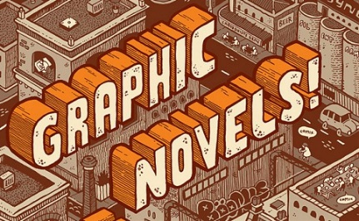

SY2015 Peirce International School:
Graphic Novel Unit – Debatable Issues

El Deafo (2014), by Cece Bell – Debatable Issues

Issue #1
Despite her partial deafness and the communication difficulties that it creates, Cece is understood and appreciated by her classmates and peers.
Issue #2
Cece embraces her deafness as a unique and positive part of herself to the point that she would not exchange it for normal hearing if she could.

Drama (2012), by Raina Telgemeier – Debatable Issue

Drama teaches us that middle school age young people are made happier by achievement at school – in class or in an after-school program like drama club – than they are by personal relationships, including romantic ones.

Snoop Troop (2014), by Kirk Scroggs – Debatable Issue

Logan and Gustavo are smart detectives.

The Arrival (2006), by Shaun Tan – Debatable Issue

Australian author Shaun Tan has said that his purpose in writing The Arrival is to build empathy in readers for immigrants: ‘In Australia, people don’t stop to imagine what it’s like for some of these refugees. They just see them as a problem once they’re here, without thinking about the bigger picture.’ The novel fully succeeds in achieving this objective.

