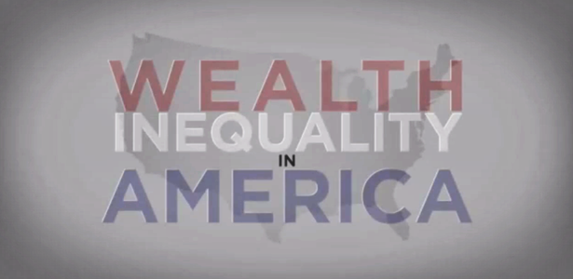

The American Income and Wealth Inequality Debate
Micro/Macro Argumentation

SIDE PREFERNCE FORM

Name: ___________________________ Period: ___________

The overall debatable issue for this project is as follows:

Income and wealth inequality is the most significant economic problem in America today.

Which side of this issue do you think you would rather argue on:

Affirmative/For or Negative/Against

On a five-point scale, how strongly do you feel about this choice:
_______ Very Strongly
_______ Strongly
_______ Moderately
_______ Not Very Strongly
_______ Weakly/Very Mildly

