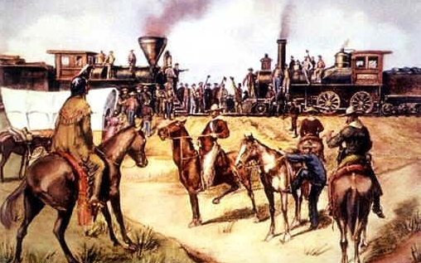
Opening the American West
Argument-Based Presentations
Presentation Template

Overview

Each student should produce a presentation (using PowerPoint, Prezy, or Google Slides) advancing a position on the debatable question:

What was the most important factor in the opening of the American
West?

Students should research their position and receive prior approval for the arguments that their presentation will make, in addition to approval for their refutation of a counter-argument.

Presentation Slide Planning Template

Each student should complete the following presentation planning template.

Name: Period:

Slide #1 – Opening

1. Hook

2. Picture

What picture will you use to grab the attention of the audience? _____________________________________________________________________________________

Card #1

What is your hook? _____________________________________________________________________________________

Background Information (most important facts to set up and provide context for your argument):

1. ___________________________________________________________________________________

2. ___________________________________________________________________________________

3. ___________________________________________________________________________________

Overall Position: _______________________________________________________________________

_____________________________________________________________________________________

Slide #2 - Argument #1

1. Claim #1 (claims must support your argumentative position, be clear, and be separate from each other):

______________________________________________________________________________________

______________________________________________________________________________________

2. Picture/Video/Document: ________________________________________________________________

Card #2

After you state your claim, what will say about the picture/video/doc that highlights its value as evidence?

______________________________________________________________________________________

______________________________________________________________________________________

______________________________________________________________________________________

Provide reasoning: how is the evidence in your picture/video/doc helping to prove your argumentative claim?

______________________________________________________________________________________

______________________________________________________________________________________

______________________________________________________________________________________

Slide #3 - Argument #2

1. Claim #2 (claims must support your argumentative position, be clear, and be separate from each other):

______________________________________________________________________________________

______________________________________________________________________________________

2. Picture/Video/Document: ________________________________________________________________

Card #3

After you state your claim, what will say about the picture/video/doc that highlights its value as evidence?

______________________________________________________________________________________

______________________________________________________________________________________

______________________________________________________________________________________

Provide reasoning: how is the evidence in your picture/video/doc helping to prove your argumentative claim?

______________________________________________________________________________________

______________________________________________________________________________________

______________________________________________________________________________________

Slide #4 - Argument #3

1. Claim #3 (claims must support your argumentative position, be clear, and be separate from each other):

______________________________________________________________________________________

______________________________________________________________________________________

2. Picture/Video/Document: ________________________________________________________________

Card #4

After you state your claim, what will say about the picture/video/doc that highlights its value as evidence?

______________________________________________________________________________________

______________________________________________________________________________________

______________________________________________________________________________________

Provide reasoning: how is the evidence in your picture/video/doc helping to prove your argumentative claim?

______________________________________________________________________________________

______________________________________________________________________________________

______________________________________________________________________________________

Slide #5 – Refutation of a Counter-Argument

1. Counter-Argument: _____________________________________________________________________

_______________________________________________________________________________________

2. Refutation of the Counter-Argument: _______________________________________________________

_______________________________________________________________________________________

Card #5
Summary of the strongest counter-argument against your position:
Some people argue that ____________________________________________________________________

________________________________________________________________________________________

Support (reasoning or evidence) for the counter-argument:
They have this view because ________________________________________________________________

________________________________________________________________________________________

Refutation of the counter-argument (why the counter-argument is wrong or does not undermine your position):
________________________________________________________________________________________

________________________________________________________________________________________

________________________________________________________________________________________

Slide #6 – Conclusion

1. Concise summary of your arguments, refutation of the counter-argument, and statement of your position: ______________________________________________________________________________________

______________________________________________________________________________________

2. Picture:_____________________________________________________________________________

Card #5

What will you highlight about the picture? _____________________________________________________

______________________________________________________________________________________

How does this picture summarize your overall position and arguments?

______________________________________________________________________________________

______________________________________________________________________________________

Effective Ending: This should be similar to your hook and leave an impression on your audience. It should also make your arguments memorable and make the audience believe you have the strongest position on what was most responsible for the Opening of the West. ______________________________________________________________________________________

______________________________________________________________________________________

______________________________________________________________________________________

