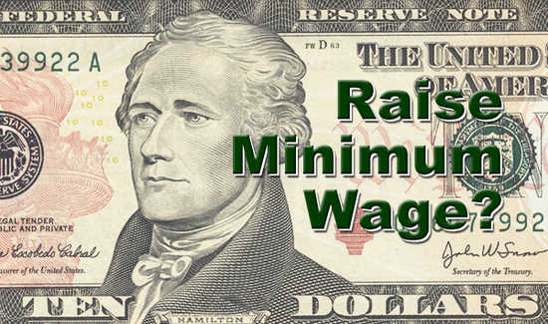

Micro/Macro Argumentation
The Minimum Wage Debate
ASSESSMENT FORM

Name:
Date:

Component Argument Counter-Argument TOTAL

Content Knowledge

Argumentative Claims

Evidence

Refutation

Evaluation

GRAND TOTAL

