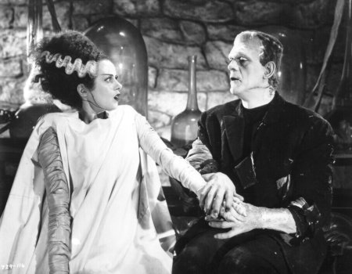

Frankenstein, by Mary Shelley (1818)
Intra-Textual Debate (Ch.17) on the Monster’s Bride

Overview

This activity explores the debate that takes place within the text of Frankenstein, beginning and lasting longest in chapter 17. The monster ended his recounting of his brief existence, told over the previous six chapters, by declaring that he wants Frankenstein to create for him a companion, a monster bride. Frankenstein and the monster then engage in a sustained argumentative exchange, something close to a debate, on whether Frankenstein should or should not undertake the making of a monster bride. Claims, counter-claims – arguments, counter-arguments, rebuttal, and refutation – all of this is to be found in chapter 17, and then later in chapters 20 and 24, when this debate is revived and concluded.

This activity focuses on the academic argumentation “key components” of summary and evidence. It highlights summary by demonstrating how passages from the novel are summarized on the flow sheet, and it exercises skills with evidence by requiring students to align argument summaries with passages from the novel. The activity also has students evaluating the argumentation in the debate. It aligns with a flow sheet that tracks the arguments and responses made by the two lead characters in the novel during the course of chapter 17.

Name: ___________________________ Period: __________

Directions

Looking at the flow sheet of the intra-textual debate between Frankenstein and the monster, choose any four arguments made by each character (so eight arguments total) from the set below, and find and copy out the quotation from the text in chapter 17 in which that character makes that argument. Be sure to identify the speaker prior to the quotation.

Model

Argument: R2.9

Passage:

The monster: “‘You, my creator, would tear me to pieces and triumph; remember that, and tell me
why should I pity man more than he pities me? You would not call it murder if you could
precipitate me into one of those ice-rifts and destroy my frame, the work of your own hands. Shall
I respect man when he condemns me?’”

The R refers to a “round number” designation that has been placed on the argumentational exchange that the two characters have. It is not part of the written text; it is an organizational feature added for the purposes of analyzing the debate. The second number after the R refers to the row number in the flow sheet. So, for example, R1.8-9 refers to the argument made in round 1, coming in the 8th/9th rows of the sheet.

Green refers to arguments made by Frankenstein. Blue refers to arguments made by the monster. Remember that you have to choose five arguments from each character.

R1.8-9 R2.4-6 R4.4-6

R4.8-9 R6.4-6 R6.8-9

R8.4-5 R8.6 R8.8-9

R1.4-6 R3.4 R3.5
R3.6 R3.8-9 R5.4-6
R5.8 R5.9 R7.8-9

1. Argument:

Passage:

2. Argument:

Passage:

3. Argument:

Passage:

4. Argument:

Passage:

5. Argument:

Passage:

6. Argument:

Passage:

7. Argument:

Passage:

8. Argument:

Passage:

Short-Response Arguments

For each of the following questions, write out your arguments in response in 2 – 3 short paragraphs per question.

9. Frankenstein ends chapter 17 agreeing to create a bride for the monster – essentially conceding the debate to the monster. Explain why his concession of the debate was justified, and why the monster had the better argumentation.

10. How could Frankenstein have won this debate in chapter 17? What arguments would he have had to make (that he didn’t) in order to have had the superior arguments? Or do you think he actually did win the debate, and he should not have conceded? Explain with reference to the text.

