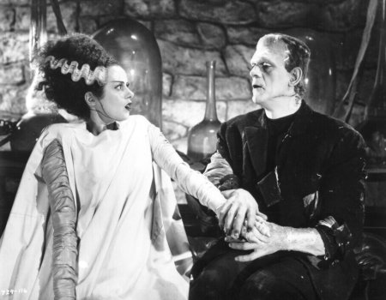

Frankenstein, by Mary Shelley (1818)
Intra-Textual Debate (Ch.20 & 24) on the Monster’s Bride

Overview

This activity explores the debate that takes place within the text of Frankenstein, picking up again in chapters 20, after Frankenstein destroys the monster’s bride before completion, and then in finality in chapter 24, after Frankenstein is dead. Claims, counter-claims – arguments, counter-arguments, rebuttal, and refutation – all of these are to be found in chapter2 20 & 24, in the dramatic conclusion of this debate between characters

This activity focuses on the academic argumentation “key components” of summary and evidence. It highlights summary by demonstrating how passages from the novel are summarized on the flow sheet, and it exercises skills with evidence by requiring students to align argument summaries with passages from the novel. The activity also has students evaluating the argumentation in the debate. It aligns with a flow sheet that tracks the arguments and responses made by the two lead characters in the novel during the course of chapters 20 & 24.

Name: ___________________________ Period: __________

Directions

Looking at the flow sheet of the intra-textual debate between Frankenstein and the monster, choose any three arguments made by each character (so six arguments total) from the set below, and find and copy out the quotation from the text in chapters 20 or 24 in which that character makes the argument. Be sure to identify the chapter number and speaker prior to the quotation.

Model

Argument: R10.9

Passage:

Frankenstein (ch.24): “Urged by this view, I refused, and I did right in refusing, and I did right in
refusing, to create a companion for the first creature.”

The R refers to a “round number” designation that has been placed on the argumentational exchange that the two characters have. It is not part of the written text; it is an organizational feature added for the purposes of analyzing the debate. The second number after the R refers to the row number in the flow sheet. So, for example, R1.8-9 refers to the argument made in round 1, coming in the 8th/9th rows of the sheet.

Green refers to arguments made by Frankenstein. Blue refers to arguments made by the monster. Remember that you have to choose three arguments made by each character.

R9.4 R9.5 R9.6

R9.7 R10.4-7 R10.10

R9.9 R9.10 R9.11
R11.4-6 R11.7 R11.9-10

1. Argument:

Passage:

2. Argument:

Passage:

3. Argument:

Passage:

4. Argument:

Passage:

5. Argument:

Passage:

6. Argument:

Passage:

Short-Response Arguments
For each of the following questions, write out your arguments in response in 2 – 3 short paragraphs per question.

7. Frankenstein makes arguments about the threat that creating a monster’s bride would pose to mankind, particularly in chapter 20, that the monster doesn’t directly or fully answer. What are those arguments and what implications do they have on the debate as a whole?

8. In what 2 - 3 ways does this debate demonstrate and underline the novel’s Romanticism?

