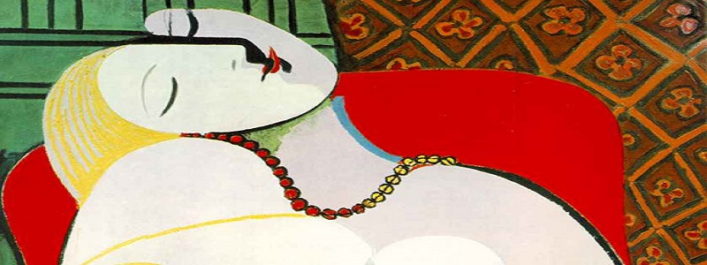
Theory of Knowledge: Art
Five Modern North American and European Artists:
Debatable Issues

In completing the content of their e-books, students should choose one of the three debatable issues listed for their artist, or identify a debatable issue themselves (getting approval for their own debatable issue). E-books should include a clear statement of the student’s position on the debatable issue. The e-books should also make arguments to support and develop the position, and address at least strong counter-argument against the position. Every page of the e-book should have some argumentational content.

Frida Kahlo

Though her paintings contain important elements from both traditions, ultimately Frida Kahlo’s art reveals a resistance if not downright hostility to European influences in favor of indigenous Mexican imagery and artistic styles.

The personal paintings of Frida Kahlo demonstrate quite clearly that her marriage to Mexican muralist Diego Rivera was unhappy and oppressive.

Frida Kahlo painted much more to express her personal, private psyche than she did to express her views about public matters, such as gender relations, cultural hegemony, politics, or economics.
Claude Monet

Most critics of the 1870s initially reacted negatively to the work of Monet
and the other artists who (thanks to Monet) came to be called Impressionists – for example, this comment in a newspaper of the time: “The impression produced by the Impressionists is that of a cat walking on the keys of a piano, or a monkey that has got hold of a box of paints.” These critics were entirely incorrect and entirely missed the mark in assessing Monet’s work.

Repetition – as in the great haystacks and water lilies series – is essential to Monet’s artistic impact.

Color ultimately plays a more profound role in the aesthetic effect of Monet’s paintings than does form or shape.

Georgia O’Keefe

Georgia O’Keefe’s art celebrates and glorifies liberated female sexuality.

Georgia O’Keefe is often thought of as brilliant American nature painter,
but her most accomplished works either do not depict nature or are not about nature.

Georgia O’Keefe had a very significant, observable influence on American modernist and American women painters both of her generation and of subsequent generations.

Pablo Picasso

Was Picasso’s work (and the artist himself) misogynistic and exploitative, or was he actually a feminist, depicting the power of women in his work and life?

Picasso’s art expresses a belief in “primitivism” – the view of some Modernists that tribal peoples from non-industrialized societies possess superior virtue and creativity.

Picasso famously said that “painting is an instrument of war.” Picasso’s greatest works demonstrate this adage.

Jackson Pollock

When casual observers comment that Jackson Pollock’s paintings look easy to make, might have been “original” but don’t require any great talent, and “any 7-year old could do the same thing,” they reveal how little they know about art. In reality, Jackson Pollock’s “drip” paintings are unique, finely crafted works of artistic genius, which would be impossible to reproduce by an amateur.

Jackson Pollock is generally regarded as one of the key founders of the American art movement called Abstract Expressionism. However, Pollock’s paintings are neither abstract nor expressionist.

Although Jackson Pollock’s major works contain no figures and are non-representational, they are uniquely American: they express and could only be created within the United States during the mid 20th century.

Diego Rivera

Although Diego Rivera was a communist, his murals were more concerned with populist, democratic equality and the triumph of reason over faith than they were statements about the superiority of communism over capitalism as an economic system.

Diego Rivera’s career demonstrated that public art works can have a significant impact on the political-economic system of a country.

In destroying Rivera’s mural Man at the Crossroads, the Rockefellers violated the artist’s right of free expression and committed an authoritarian act of censorship.

