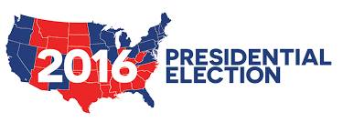

The 2016 Presidential Election Simulation
IMPLEMENTATION TIMELINE

May 2nd Project finalized

May 4th Candidates and campaign teams identified

May 9th Campaigning begins

May 16th Campaigning continues

“PA Days” begin

May 26th Presidential Debate

May 27th Election

May 30th Election results announced

