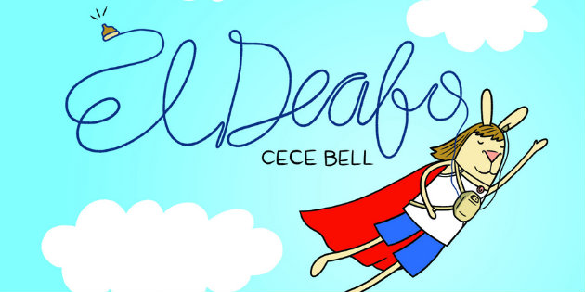

El Deafo, by Cece Bell (2012)
Argument Writing Response Activity
Implementation Plan

Week 1 (5/31)
- Introduction of the novel and of the debatable issue
- Guided reading of the first two chapter-clusters (1 – 5, 6 – 10)
- Classroom-wide discussion of guided questions, including quick-write preparation of responses
- Spot student theatre performances of sections of the graphic novel

Week 2 (6/6)
- Guided reading of the next two chapter-clusters (11 – 15, 16 – 21)
- Small-group discussion of guided questions, including argument preparation activities
- Spot student theatre performances of sections of the graphic novel

Week 3 (6/13)
- Assign students by argument
- Argument Writing Response Activity
- Apply AWRA product to the argument writing outline to produce interpretive argument short essays
- Presentation of select interpretive argument short essays

