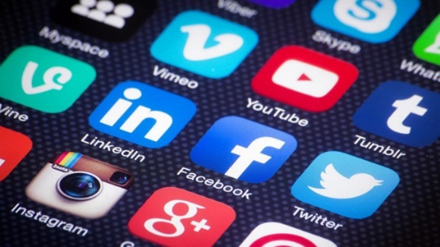
Social Media Debate
Media List

The debatable issue for this project is:

Social media makes teenagers less social.

Background Information/Both Sides

https://sites.psu.edu/siowfa15/2015/09/16/is-technology-really-making-us-less-social/
A Penn State University course resource summarizes the arguments of several leading academics on either side of this issue.

http://lorirtaylor.com/has-social-media-made-us-less-social/
The media blog Social Caffeine has both good and bad things to say about the impact of social media on social lives. Social media use makes people more anxious, less connected to their families, and feeling lonelier, according to data cited in the post. But social media also builds personal networks that can bring people new opportunities, if they use their network well.

Affirmative/Social Media Harmful

https://www.youtube.com/watch?v=K7m1RwVxRoo
[Video, 15 minutes] The Child Development Institute’s 2015 documentary titled “Not So Social Media” lays out the several significant ways that social media harms teens – leads to bullying, exploitation, violence.

http://www.cnbc.com/2015/10/15/social-media-making-millennials-less-social-study.html
A FlashGap study reported by CNBC (October 17, 2015) says that most millennials miss on actual social interactions in favor of posting or checking social media. They also regret posts that they make. But FlashGap states that there are a few apps that counter the negative implications of social media.

http://www.cnn.com/2015/11/03/health/teens-tweens-media-screen-use-report/
CNN reports (November 3, 2015) on a Common Sense Media study of teens’ and tweens’ social media use. Teens are on social media an average of 9 hours per day (!), which means they are generally on social media while doing homework, which is impeding their educations. Despite all that time on social media, only 10% of teens report really enjoying it.

https://psmag.com/even-just-the-presence-of-a-smartphone-lowers-the-quality-of-in-person-conversations-4b518f657b32#.cw0oslinc
Pacific Standard reports (July 14, 2014) on a Virginia Tech University study which concluded that just the presence of social media connected devices undermines the intimacy and empathy of in-person conversations.

http://www.theguardian.com/commentisfree/2015/sep/16/social-media-mental-health-teenagers-government-pshe-lessons
New research explained by The Guardian (September 15, 2015) shows that social media is harming teenagers’ mental health, especially the mental health of teenage girls.

http://townhall.com/columnists/christinerousselle/2015/01/31/social-media-is-making-us-antisocial-n1950924
A Townhall writer (January 31, 2015) says that social media platforms make people dependent on them. They also dilute what the word “friend” means, along with facilitating relationship-ending affairs.

Negative/Social Media Helpful

https://www.youtube.com/watch?v=CaXksgHW034
[Video, 2.5 minutes] University of California Irvine professor describing research that shows that teens use social media to connect with new people, and to develop healthy and positive relationships.

https://www.youtube.com/watch?v=qgf5QIpttRw
[Video, 3 minutes] The CASE Foundation makes the argument that social media is connecting the world in a way that is leading to significantly more charitable giving and volunteer work.

https://www.youtube.com/watch?v=Uppg_2nGo54
[Video, 3 minutes] University of East Anglia video on the power of social media to effect political and social change.

http://www.techrepublic.com/article/are-smartphones-are-making-us-less-social/
A Tech Republic article (December 8, 2014) states that the distractions caused by social media are nothing new; people have always been bored and distracted at times. Social media does do two important things: (a) keeps us in potential contact with our friends at all times, and (b) introduces us to people around the world, making the world a smaller place.

http://www.theguardian.com/lifeandstyle/2013/oct/05/teens-social-networking-good-for-them
The Guardian (October 5, 2013) reports that evidence is accumulating that there are a wide variety of benefits that teens incur in their use of social media.

http://www.pewinternet.org/2015/08/06/chapter-4-social-media-and-friendships/
A Pew Research Center (August 6, 2015) study found that teens feel support from family and friends on social media when they are facing difficulties, and though they feel some pressure to post good things about themselves and to curate a self-image on social media, they don’t feel negatively about themselves when using social media.

http://www.huffingtonpost.com/molly-reynolds/is-social-media-actually-_b_4867841.html
New social media platforms are moving to facilitating real-life social interactions, as opposed to keeping interactions digital.

