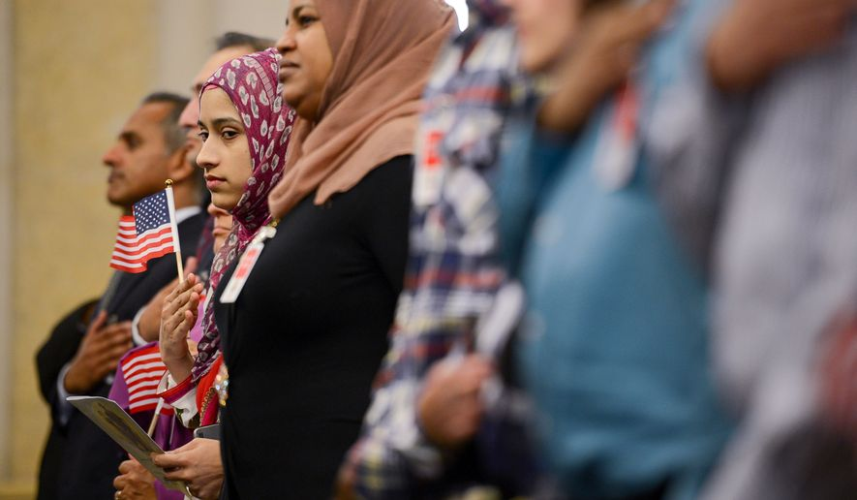
Targeted Instructional Area: Argument Writing
Immigration from the Middle East Media List

Issue: Because of the threat of terrorism, residents of Middle Eastern countries should be given significantly greater scrutiny before being allowed to immigrate into the United States.

Background Information/Both Sides

http://junior.scholastic.com/breaking-news/2015/12/Obama-Speaks-on-Terrorism
Following the San Bernadino shooting, President Obama lays out his plan for combating the threat of ISIS without targeting Muslims. Republicans criticize it as not going far enough.

http://www.nbcnews.com/politics/2016-election/donald-trump-shifts-muslim-ban-calls-extreme-vetting-n611276
Republican presidential nominee Donald Trump articulates the policy of ‘extreme vetting’ of Middle Eastern prospective immigrants.

http://cis.org/MiddleEasternImmigrantsProfile
Center for Immigration Studies – which calls itself, ‘Low-Immigration, Pro-Immigrant’ – lays out quantitative data on immigration to the U.S. from Middle Eastern countries. The article doesn’t take argue for a position on the issue, though it does assert both that immigration should be reduced and that no one region should be targeted for reductions.

http://www.pewresearch.org/fact-tank/2016/07/22/muslims-and-islam-key-findings-in-the-u-s-and-around-the-world/
The highly respected Pew Research Center publishes survey data about Muslim persons’ attitudes about ISIS and the West.

Affirmative/Middle Eastern Residents Should Scrutinized Much More Closely

https://www.youtube.com/watch?v=NuCkggoGP3c
[Video] Sen. Rand Paul (R – KY) argues on Fox News that the U.S. needs to place a temporary moratorium on immigration from the Middle East, for national security reasons.

http://www.nationalreview.com/article/396262/troubling-math-muslim-migration-ian-tuttle
Immigration of Muslims from the Middle East is simply a mathematical threat: the more the U.S. allows in, the greater the chance that radical Islam will present a threat of terrorism in the U.S.

http://time.com/4367120/orlando-shooting-donald-trump-transcript/
Republican presidential nominee Donald Trump’s speech (full transcript) after the Orlando nightclub bombing in June. Political correctness is preventing the U.S. from being smart and tough about immigration. Radical Islam is posing a threat to lives and the quality of life in the United States, and immigration policies have to be revised to reflect that.

http://www.thedailybeast.com/articles/2015/09/04/the-middle-east-needs-to-take-care-of-its-own-refugees.html
The Muslim refugee crisis in the Middle East should be solved by wealthy Muslim countries in the Middle East, not by Western democracies. Countries like Saudi Arabia and Qatar have taken zero Syrian refugees. It is not the moral obligation of the Europe and the U.S. to take Middle Eastern refugees, it is much more the obligation of countries in the region to do so.

http://www.cnsnews.com/news/article/melanie-hunter/fbi-director-admits-us-will-have-no-basis-vet-some-syrian-refugees
The FBI states that screening persons coming into the country from Iraq is feasible, given how long the U.S. has been in Iraq in large numbers, but that screening from countries like Syria cannot be effective for persons in that country who have maintained a low profile.

http://www.politico.com/story/2016/06/huckabee-likens-trumps-muslim-ban-to-israels-immigration-policies-224458
Scrutinizing Middle Eastern residents before entering the country is currently done effectively by the state of Israel.

http://theweek.com/articles/630078/dont-let-donald-trumps-wild-antimuslim-rhetoric-obscure-real-threat-islamic-extremism
Trump’s rhetoric is intemperate, but he’s right on the issue of immigration from the Middle East.

Negative/Middle Eastern Residents Should Be Given Equal Scrutiny

http://www.ibtimes.com/terrorism-attacks-911-have-involved-us-citizens-not-immigrants-despite-gop-debate-2228202
Two important facts that Republicans get wrong when they connect the threat of terrorism in the U.S. to immigration from the Middle East: the overall threat level from terrorism in the U.S. is relatively low, by historical standards, and most terrorism in the U.S. is carried out by American citizens born in the U.S. (even if some of them are Muslim), not immigrants.

https://www.youtube.com/watch?v=Xzkkk-oJ6bo
[Video] Khizr Khan speaks at the Democratic National Convention about what he calls Trump’s ignorant Islamophobia.

http://www.politifact.com/truth-o-meter/statements/2016/jun/13/donald-trump/wrong-donald-trump-says-theres-no-system-vet-refug/
The United States has a very robust and careful screening system currently in place for refugees from the Middle East, one that more than two years for each individual applicant to go through.

http://www.thefiscaltimes.com/Columns/2016/03/10/Trump-Presidency-Could-Give-ISIS-Foothold-US
Islamaphobic policies promoted by Trump could deepen the alienation of the 3 million Muslims living in the U.S., making a ISIS-inspired terrorism in the U.S. more likely.

http://www.vice.com/read/we-asked-an-expert-how-trumps-anti-muslim-immigration-policy-would-work
Two immigration experts (from New York University School of Law and the University of Virginia School of Law) make several brief points against Trump’s policy: (a) it would be very difficult to implement, (b) it would result in retaliation by Middle Eastern countries, hurting our business and diplomatic ties, and (c) it didn’t improve national security when a similar provision was tried in the 2002 Homeland Security Act.

http://www.realclearpolitics.com/articles/2016/06/13/clinton_trumps_anti-muslim_talk_increases_us_risks.html
Democratic presidential nominee Hillary Clinton says that policies targeting immigration from the Middle East are immoral, anti-American, and unnecessary.

https://www.washingtonpost.com/blogs/post-partisan/wp/2016/06/13/trumps-islamophobia-helps-to-motivate-the-islamic-state/
Trump’s immigration policy threatens to further polarize the Middle East and strengthen the hold of ISIS there on millions of people, young men in particular.

