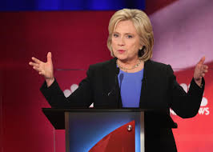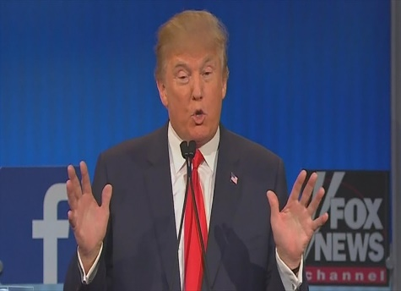

2016 Presidential Debates
Analytic Evaluator (aka TV Pundit) Form

Name:

Period:

Issue Category:

Hilary Clinton: Positions and Arguments

Position 1

Argument for the position (include evidence and reasoning)

Donald Trump’s counter-arguments

Hilary Clinton’s rebuttal to the counter-arguments

Hilary Clinton: Positions and Arguments

Position 2

Argument for the position (include evidence and reasoning)

Donald Trump’s counter-arguments

Hilary Clinton’s rebuttal to the counter-arguments

Donald Trump: Positions and Arguments

Position 1

Argument for the position (include evidence and reasoning)

Hilary Clinton’s counter-arguments

Donald Trump’s rebuttal to the counter-arguments

Donald Trump: Positions and Arguments

Position 2

Argument for the position (include evidence and reasoning)

Hilary Clinton’s counter-arguments

Donald Trump’s rebuttal to the counter-arguments

Debate Evaluation

Based on the evidence and reasoning presented by both sides, who won HC position #1 and why:

Based on the evidence and reasoning presented by both sides, who won HC position #2 and why:

Based on the evidence and reasoning presented by both sides, who won DT position #1 and why:

Based on the evidence and reasoning presented by both sides, who won DT position #2 and why:

Looking communication and presentation style, evaluate who had the better performance based on the specified criteria:
Tone:

-------------------------------------------------------------------------------------------------------------------------
Self-confidence/authority:

-------------------------------------------------------------------------------------------------------------------------
Use of language

-------------------------------------------------------------------------------------------------------------------------
Overall stylistic impact:

Based primarily on the argumentation in the debate, evaluate who won and why:

