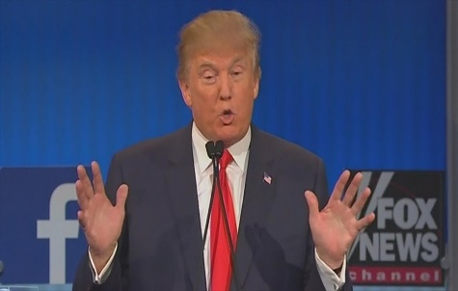

2016 Presidential Debates
Analytic Evaluator (aka TV Pundit) Form Model

Donald Trump Position 1

Donald Trump’s tax plan would reduce taxes for all current tax players by setting up three
brackets: 15%, 25%, and 33%, with no taxes paid by those making $38,000 or less.

Argument for the position (include evidence and reasoning)

Claim: This tax plan would increase economic growth and lower unemployment.
Evidence and Reasoning: The Institute for Tax Policy has concluded that this tax plan will raise
economic growth to 3.5% annually. The main reason for this is that it will put more money in the
hands of taxpayers, which will circulate through the economy and help American businesses.

Hilary Clinton’s counter-arguments

(1) The Institute for Tax Policy is a biased, right-wing source. The more neutral Congressional
Budget Office said that this policy will add $4.5 trillion to the national debt. It will destroy the
economy over the longer term. (2) This tax policy gives hundreds of billions in tax breaks every
year to the rich. Trump himself will receive $6 million a year in reduced taxes from his own policy.
The tax policy is more economic injustice, the opposite of what we need.

Donald Trump’s rebuttal to the counter-arguments

(1) Clinton doesn’t know anything about economics. She has never hired anyone in her life and
never earned a living in the private sector. (2) This tax policy will get the economy moving again.

