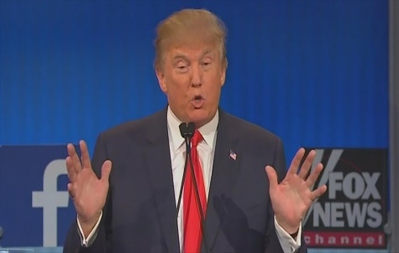

2016 Presidential Debates
Analytic Evaluator (aka TV Pundit) Rubric

Position/Argumentation
Up to 2 points per field, and 8 points total. (When grading the group’s official AEF, count the top two position/arguments.)

2 Points The summary is very clear and grammatically expressed. All (or almost all) of the
content is accurate, significant, and well selected.

1 Point The summary is partially clear, with some mechanical obstacles to understanding it.
Much but not all (or almost all) of the content is accurate, significant, and well
selected.

0 Points The summary is unclear. The content is either very meager, or its content contains significant inaccuracies, or it is insignificant or poorly selected.

Stylistic Evaluation
Up to 8 points.

7-8 Points Insightful analysis of style. Compelling comparative evaluation. Strong examples.

5-6 Points Solid analysis of style. Reasonable comparative evaluation. Relevant examples.

3-4 Points Partially effective analysis of style. Incomplete comparative evaluation. Few examples.

1-2 Points Mostly ineffective analysis of style. Failed comparative evaluation. Examples don’t work well.

0 Points Nothing that counts as stylistic evaluation.
Overall Evaluation
Up to 10 points.

9-10 Points Highly insightful analytical evaluation of the competing argumentation. Clear and
compelling reasons that one or the other candidate won the debate. Aligned, sufficient, and well-chosen examples to support the reasons.

7-8 Points Solid, cogent analytical evaluation of the competing argumentation. Sensible, justifiable
reasons that one or the other candidate won the debate. Mostly aligned and nearly sufficient examples to support the reasons.

5-6 Points Mostly reasonable but partially effective evaluation of the competing argumentation.
Reasons are partially convincing, partially unconvincing, that one candidate or the other won the debate. Examples are partially aligned and sufficient to support the reasons.

3-4 Points Limited effectiveness of the evaluation of competing argumentation. Reasons that one
candidate or the other won the debate mostly do not convince, likely because they are not closely connected to the issue debates summarized. Only one or two relevant examples, insufficient to support the conclusions.

1-2 Points Failed attempt at the evaluation of competing argumentation. Reasons for identifying one
candidate as the winner of the debate are offered, but they don’t succeed. An attempt to offer supporting examples, but they have little to no connection to the issue debate summaries, and they are not effective.

0 Points No real overall evaluation.

