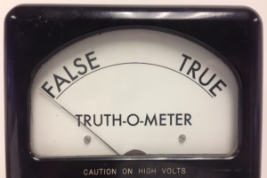
2016 Presidential Debates
Fact Checker Form

Name(s):

Class:

Period:

Fact Check Correction #1

Candidate (Circle or highlight one): Hillary Clinton Donald Trump

Evidence presented

Argumentative claim that it was used to support

Evidence correction (include the source you used to determine the true facts)

Implications this fact checking has on the specific argumentation and the issue as a whole

Fact Check Correction #2

Candidate (Circle or highlight one): Hillary Clinton Donald Trump

Evidence presented

Argumentative claim that it was used to support

Evidence correction (include the source you used to determine the true facts)

Implications this fact checking has on the specific argumentation and the issue as a whole

Fact Check Correction #3

Candidate (Circle or highlight one): Hillary Clinton Donald Trump

Evidence presented

Argumentative claim that it was used to support

Evidence correction (include the source you used to determine the true facts)

Implications this fact checking has on the specific argumentation and the issue as a whole

