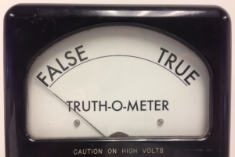
2016 Presidential Debates
Fact Checker Form – MODEL

Candidate (Circle or highlight one): Hillary Clinton Donald Trump

Evidence presented

Donald Trump stated at the Republican National Convention that “only I can solve the problems”
that we face in the U.S. This is evidence that he is an egotistical person unfit for the role of
President, which requires consensus-building and teamwork.

Argumentative claim that it was used to support

Donald Trump is too much of an ego-maniac to make an effective president. He is not
temperamentally qualified to be president.

Evidence correction (include the source you used to determine the true facts)

Donald Trump did say “only I can solve the problems” at the Republican National Convention,
but he was referring to his knowledge of the ways that elected officials are influenced by
contributors’ donations. Trump was for many years a big contributor to many elected officials. He
went on to say at the RNC that he will work with a wide range of people to put his reforms into
effect. The source here is PolitiFact.org, accessed 9/24/16.

Implications this fact checking has on the specific argumentation and the issue as a whole

Hilary Clinton used other evidence in this debate to try to prove that Donald Trump is not
temperamentally fit to be president, but her most prominent piece of evidence, which she repeated
several times in the course of the debate, was the evidence that Trump stated at the Republican
National Convention that he can solve the nation’s problems by himself. The evidence doesn’t
support this claim – Trump meant that he is uniquely qualified to address the U.S. government’s
problems, not that he can solve them single-handedly. Thus, Clinton’s argument that Trump is
not qualified to be president was significantly weakened by this fact check.

