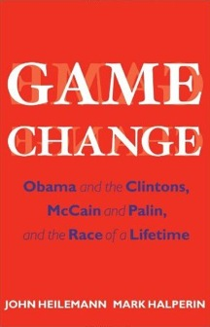

Game Change (2010)
Chapter 6: “Barack in a Box”
Guided Reflection Questions

Primary Debatable Issue for the Unit

What is the most important factor in being elected President in modern American
politics?

Directions

Students can work in groups, in pairs, or individually on these guided reflection questions. Then a teacher-led discussion can help students understand the text as a source of evidence for arguments on the debatable issue.

1. What three adjectives would you use to describe the group of advisers that Obama meets with to begin to strategize his run for the presidency in February 2007?

2. What, according to Game Change, was Obama’s single greatest attribute as a young and inexperienced presidential candidate? Why do you think this attribute was so important?

3. Identify and describe some of the reasons that, in the spring and summer of 2007, Barack Obama was having a very unpleasant time of it as a presidential candidate.

4. What image did the early Democratic primary debates begin to solidify for the media of each of the three candidates: Hillary Clinton, John Edwards, and Barack Obama?

5. How did Obama’s friend Chris Edley shake up the campaign in the summer of 2007? What did he think it was essential to emphasize, and allow the candidate to emphasize, going forward?

6. The last five pages or so of the chapter recount Obama’s struggle with two campaign strategies: how to criticize (in political campaign parlance, “go negative” against) Hillary, and how to struggle for and win the “change” mantel. Describe the strategic decisions the Obama campaign makes on these two questions.

