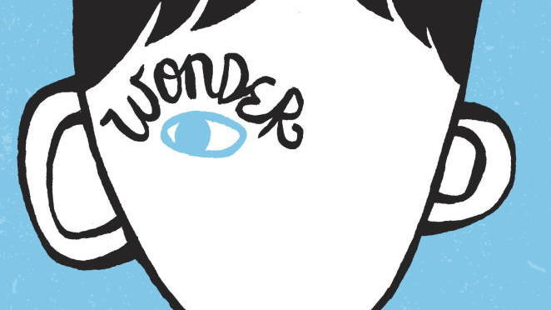
Wonder, by R. J. Palacio (2012)
Evidence Finding Activity

Debatable Issue: Does Auggie Pullman end up a fully accepted member of his school and community, despite his physical deformity?

Overview

When we read literature – stories, novels, plays, poems – in school we try to figure out what we are reading means. We try to figure out what the story or book is trying to tell us. Stories have always functioned in civilization as a means of communicating ideas, lessons, and insights, often times especially about life and how we should live our lives. This work to make meaning out of literature is called interpretation. We interpret literature by making what are called claims about what it means. We back up those claims with evidence from the text that we think supports our claims. These evidence-backed claims are called interpretive arguments.

Interpretive arguments are often made in response to questions that the work of literature explores. These questions are called debatable issues. For the young adult novel Wonder, the debatable issue that this activity will have us think hard about is the question about the lead character Auggie Pullman highlighted above.

Directions

For each of the following claims made that are related to the debatable issue, find a passage from the specified page numbers that supports the claim. Quote or summarize the passage. Then explain how the passage supports the claim. Finally, be prepared to share which side of the issue this interpretive argument (the claim + the evidence to support the claim) would help support.

(1) Claim: Summer Dawson goes out of her way to befriend Auggie.

Evidence (from pp.51-53):

Explain how this evidence supports the claim:

(2) Claim: The Pullman family gives Auggie a great deal of love, but they cannot change his
appearance.
Evidence (from pp. 58-60):

Explain how this evidence supports the claim:

(3) Claim: Auggie is smart enough to know that most other kids react to his appearance not out of hatred or evil, but simply because it is so unusual and strange.
Evidence (from pp. 61-62):

Explain how this evidence supports the claim:

(4) Claim: The “Halloween Incident” (as it is later called) shows that Auggie cannot fully trust what his friends tell him to his face, that they might make fun of Auggie behind his back.

Evidence (from pp.76-78):

Explain how this evidence supports the claim:

(5) Claim: One of Via’s important lessons is that it is perfectly normal to have problems or challenges with other people at school, that everyone has to face these in some way or another.
Evidence (from pp. 114-115):

Explain how this evidence supports the claim:

(6) Claim: Jack appears to have been taught a lesson at a young age about kindness and thinking about other people’s feelings that influences his treatment of Auggie.

Evidence (from pp. 136-138):

Explain how this evidence supports the claim:

(7) Claim: “The Plague” and “the War” demonstrate not only that kids in middle school can be mean to kids with deformities but that peer pressure and cliques feed that unfairness.

Evidence (from pp.176-178):

Explain how this evidence supports the claim:

(8) Claim: Even Auggie’s sister Via is embarrassed of her brother when she enters high
school and her social surroundings begin to change.
Evidence (from pp. 217-219):

Explain how this evidence supports the claim:

(9) Claim: At times it appears to Auggie that he’ll have to be interacting with his dog or with
people only after he dies and goes to heaven if he wants his face not to be a big distraction.
Evidence (from pp. 225-227):

Explain how this evidence supports the claim:

(10) Claim: Miranda’s relationship with Auggie seems to show that he inspires love from people even outside his immediate family.

Evidence (from pp.241-242):

Explain how this evidence supports the claim:

(11) Claim: The fight that takes place during the fifth grade nature retreat demonstrates that Auggie is always at risk of being made fun of and even physically threatened due to his deformity.
Evidence (from pp. 265-267):

Explain how this evidence supports the claim:

(12) Claim: Auggie winning the Beecher Award symbolizes the full embrace he finally receives
by his peers and his school.
Evidence (from pp. 61-62):

Explain how this evidence supports the claim:

