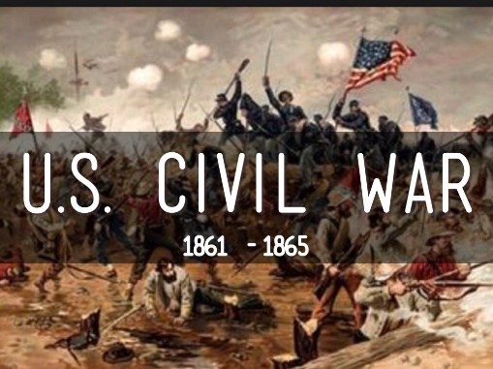

The Civil War – Final Assessment: Extended Response

Directions

Complete the following extended argument template in response to this prompt:

How did the geography of the United States motivate the Northerners and Southerners to make decisions prior to and during the Civil War?

Arguments

First Argument Paragraph

One important way that the geography of the North influenced their decision-making prior to the

Civil War was [insert argumentative claim] ____________________________________________

_____________________________________________________________________________.

When Northern leader(s) [insert name or names] _______________________________________

_______________________________________ decided to [insert decision prior to the Civil War]

______________________________________________________________________________

______________________________________________________________________________

it was because [insert geographic factor] ______________________________________________

_____________________________________________________________________________.

We know this because [insert evidence or reasoning] ____________________________________

_____________________________________________________________________________

_____________________________________________________________________________.

Second Argument Paragraph

During the Civil War itself [insert Northern leader’s(or leaders’) name(s)] _____________________

______________________________________________________________________________

decided to [insert decision] ________________________________________________________

______________________________________________________________________________

it was a direct result of [insert geographic factor] ________________________________________

______________________________________________________________________________

_____________________________________________________________________________.

Historians are justified in drawing this conclusion because [insert evidence or reasoning] _________

_____________________________________________________________________________

______________________________________________________________________________

_____________________________________________________________________________.

Third Argument Paragraph

As to the South, it was influenced by [insert argumentative claim] ___________________________

______________________________________________________________________________

leading up to the Civil War. When [insert Southern leader’s (or leaders’) name(s)] ______________

______________________________________________________________________________

[insert decision occurring prior to the Civil War] ________________________________________

______________________________________________________________________________

_____________________________________________________________________________

it was because [insert geographic factor] ______________________________________________

_____________________________________________________________________________.

The evidence that proves this is [insert evidence or reasoning] _____________________________

______________________________________________________________________________

_____________________________________________________________________________.

Fourth Argument Paragraph

Later, the South decided to fight the war by [inset decision occurring during the War] ___________

_____________________________________________________________________________.

This was clearly because [insert geographic factor] ______________________________________

_____________________________________________________________________________.

[Insert evidence or reasoning] ______________________________________________________

_____________________________________________________________________________

_____________________________________________________________________________

_____________________________________________________________________________.

