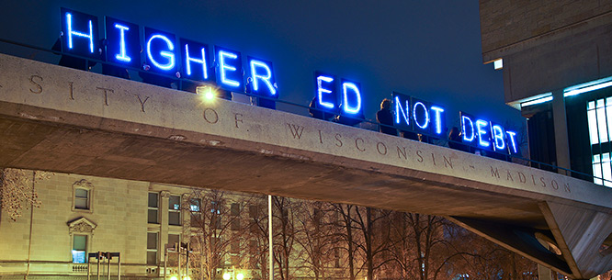

Free Public College Argument Boxing
Implementation Plan

Debatable Issue: Should public college in the United States be free?

Day 1
Introduce the project: the issue of free public college and the Argument Boxing
format.
Brainstorm list of argumentative claims.
Divide the class into four groups, assigning each group a side on the issue, two
affirmative groups and two negative groups.
Identify a leader of each group, who will be responsible for ensuring that the group
completes its work and is ready for Argument Boxing.
Distribute the two background articles.
Read them together.
Conduct classroom-wide argument-based discussion.
Revisit list of argumentative claims.

Day 2
Review the criteria for effective use of evidence: alignment, credibility, sufficiency,
and reasoning.
Distribute articles packet, by side, to each team.
Assign each team to find the six best pieces of evidence to support their position,
from at least three of the articles.

Day3
Complete article reading, annotating, and evidence finding.
Share out and discuss the best pieces of evidence found.
Showcase the best evidence and discuss which argumentative claims it supports.
Revisit list of argumentative claims.

Day 4
Distribute argument builders and counter-argument builders.
Conduct argument and counter-argument building.

Day 5
Review the Argument Boxing format.
Conduct two rounds of Argument Boxing.
Have students submit their argument and counter-argument builders for a team
assessment.
Assess each student individually for their contribution in Argument Boxing.

