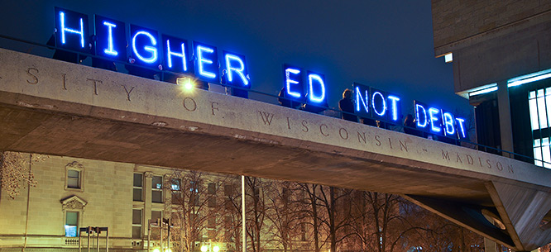
Free Public College
Document Excerpts

Debatable Issue: Should public college in the United States be free?

Document A Sara Goldrick-Rab, professor of education, University of Wisconsin at Madison, “Public Education Should Be Universal and Free,” New York Times, January 20, 2016

“Efforts to make college affordable via targeted financial aid are divisive. Families that don’t get aid resent those that do. Over time, the purchasing power of programs like the Pell Grant has eroded for lack of political support, and recipients have been denigrated as lazy, ‘academically adrift’ and akin to ‘welfare recipients.’ Compare that to the solid support for Medicare and Social Security, which offer benefits to all senior citizens.”

Document B Keith Ellison, “The Argument for Tuition-Free College,” The American Prospect, April 14, 2016

“The cost of attending a four-year college has increased by 1,122 percent since 1978. Galloping tuition hikes have made attending college more expensive today than at any point in U.S. history. At the same time, debt from student loans has become the largest form of personal debt in America—bigger than credit card debt and auto loans. Last year, 38 million American students owed more than $1.3 trillion in student loans. Today, student loan debt increases inequality and makes it harder for low-income graduates, particularly those of color, to buy a house, open a business, and start a family. Once, a degree used to mean a brighter future for college graduates, access to the middle class, and economic stability. Today, student loan debt increases inequality and makes it harder for low-income graduates, particularly those of color, to buy a house, open a business, and start a family. The solution lies in federal investments to states to lower the overall cost of public colleges and universities.”

Document C Michael Petrilli, researcher at Stanford University, “Free Tuition
Is a Needless Windfall for Affluent Voters and State Institutions,” New York Times, January 20, 2016

“Yes, it might entice more students to enroll in the first place, as advocates claim. But is that a good thing? We know from multiple sources —including the National Assessment of Educational Progress — that just 40 percent of 12th graders are college-ready, even though nearly 70 percent already head straight into college. This is why more than half of those entering many colleges start in remedial courses — high school-level classes from which most will never escape. That’s no good way to enter adulthood.”

Document D Max Page and Dan Clawson, professors, University of
Massachusetts, “It’s Time to Push for Free Public College,” NEA.org, 2010

“Studies show that there is no better short-term or long-term investment for the rest of society than higher education. For example, one study shows that new spending on public colleges, which would be sparked by an influx of more students, produces more economic activity than a similar-sized tax cut, or similar spending on roads and bridges. And, over their lives, college graduates smoke less, commit fewer crimes, draw less on social welfare programs, and generate more taxes.”

Document E Kevin James, researcher, American Enterprise Institute, “Bernie’s
Bad College Idea,” U.S. News and World Report, May 27, 2015

“Free public college would limit choice as many private institutions, now trying to compete with a highly-subsidized, free public option, would likely struggle to survive. In addition to reducing options, this would significantly reduce pressure on public institutions to serve students effectively. Many free college proponents would likely point out that by providing aid directly to institutions, the government can actually exert more direct control over how they operate. For example, Sanders' bill would require institutions to reduce their reliance on adjunct professors. But are such top-down controls really likely to create the dynamic and innovative system that we need? By trying to dictate innovation from Washington, such a proposal is more likely to create a system that is rigid, bureaucratic and unresponsive to the changing needs of students and the economy over time.”

Document F Bernie Sanders, U.S. Senator from Vermont, “Make College Free for All,” Washington Post, October 22, 2015

“An important pathway to the middle class now runs through higher education, but rising costs are making it harder and harder for ordinary Americans to get the education they want and need. In 1978, it was possible to earn enough money to pay for a year of college tuition just by working a summer job that paid minimum wage. Today, it would take a minimum wage worker an entire year to earn enough to cover the annual in-state tuition at a public university. And that’s why so many bright young people don’t go to college, don’t finish or graduate deeply in debt. With $1.3 trillion in student loans, Americans are carrying more student debt than credit card or auto-loan debt. That’s a tragedy for our young people and for our nation.”

Document G Andrew Kelly, “The High Cost of Free College,” U.S. News and World Report, February 23, 2106

“Enrollment rates: Data from the Organization for Economic Co-operation and Development indicate that the U.S. is tied for 12th out of 18 countries with available data when it comes to the share of citizens 25 and under that enroll in college, at 47 percent. Not so good, right? Especially compared to Denmark (56 percent) and Slovenia (68 percent) – two free college countries – that rank near the top. However, the countries nearest the U.S. – Germany (45 percent), Austria (47 percent) and Iceland (49 percent) – have free or very low tuition. And two countries at the bottom of the list – Sweden (40 percent) and Finland (41 percent) – offer free tuition.”

Document H Matt Bruenig, “The Case Against Free College,” The New Republic,
October 5, 2015

“At public colleges, students from the poorest fourth of the population currently pay no net tuition at either two-year or four-year institutions, while also receiving an average of $3,080 and $2,320 respectively to offset some of their annual living expenses. Richer students currently receive much fewer tuition and living grant benefits. Given these class-based differences in attendance levels, institutional selection, and current student benefit levels, making college free for everyone would almost certainly mean giving far more money to students from richer families than from poorer ones.”

Document I Eric Westervelt, National Public Radio, February 17, 2016

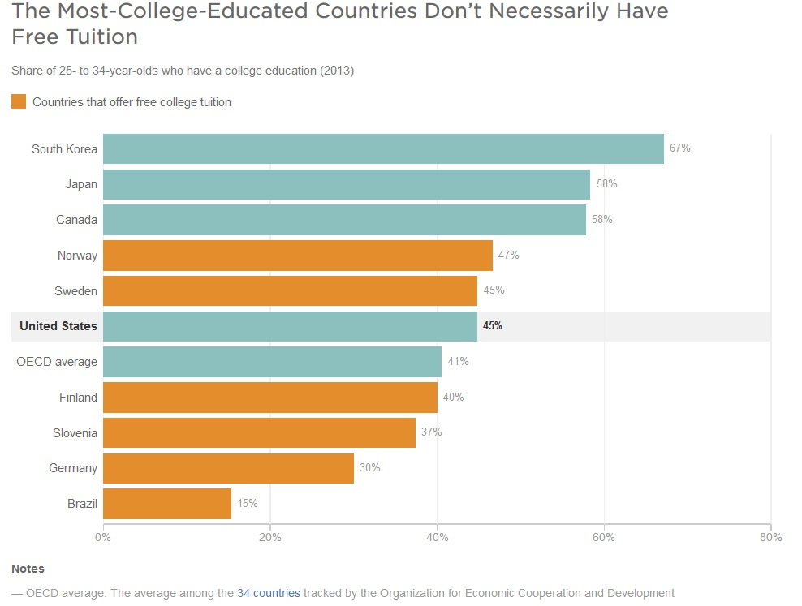

Document J Jen Luckwaldt, PayScale Human Capital, 2015

