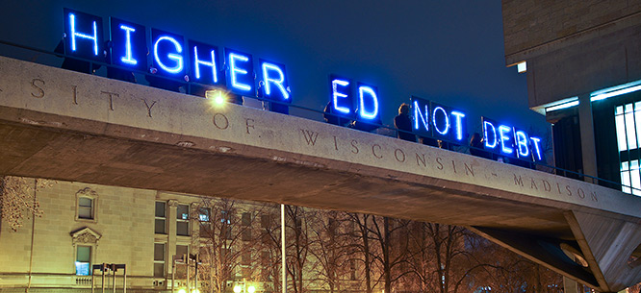

Free Public College Debates
Media List

Debatable Issue: Should public college in the United States be free?

Background/Both Sides (General)

http://www.npr.org/sections/ed/2016/02/17/466730455/fact-check-bernie-sanders-promises-free-college-will-it-work?utm_campaign=storyshare&utm_source=twitter.com&utm_medium=social
There are reasons to believe that free public college won’t achieve the goals that its advocates promise. But there are also reasons to believe that tuition is keeping lots of students from getting a college degree.

http://www.americamagazine.org/issue/college-free-all
An overview of the current state of the debate in this country over how to make college more affordable and whether to adopt a European-like free college system.

Affirmative – College Should Be Free

http://www.nytimes.com/roomfordebate/2016/01/20/should-college-be-free/public-higher-education-should-be-universal-and-free
University of Wisconsin education professor Sara Goldrick-Rab argues that maintaining political support for substantial college aid requires that all students, not just low-income students, get public college for free.

http://prospect.org/article/argument-tuition-free-college
The cost of college has grown astronomically. It is unaffordable to more and more American families. Making public college free would return the U.S. to the original 19th century idea of “land grant colleges” that were supposed to be free or very inexpensive for middle class and working class Americans.

http://www.nea.org/home/62740.htm
College education has many benefits for society, including economic benefits. These advantages make the investment in free public college well worth it.

https://www.washingtonpost.com/opinions/bernie-sanders-america-needs-free-college-now/2015/10/22/a3d05512-7685-11e5-bc80-9091021aeb69_story.html?utm_term=.264b393d6fd9
Sen. Bernie Sanders makes his case for free public college. A college degree is now a requirement to make it into the middle class, the way a high school diploma was 50 years ago. But college is totally unaffordable for the majority of young people. K-12 public education should be extended to college. Includes a video of Sen. Sanders speaking on the issue.

https://www.dissentmagazine.org/article/mike-konczal-generation-debt-free-college-argument
Student debt is becoming a major problem in this country, and is disproportionately impacting African-Americans. Student debt is having a long-term effect on people’s lives. In the post-war era, public college was basically free and it led to much higher social mobility.

Negative – College Should Not Be Free

http://www.nytimes.com/roomfordebate/2016/01/20/should-college-be-free/the-problem-is-that-free-college-isnt-free
Andrew Kelly, of the American Enterprise Institute, argues that there are two problems with free public college. (1) The public won’t fund it sufficiently to meet the demand, and many people will be unable to attend. (2) Students don’t graduate from college because they are not academically prepared. Money is a secondary problem.

http://www.usnews.com/opinion/knowledge-bank/articles/2016-02-23/bernie-sanders-and-the-high-cost-of-free-college
Comparing data from countries that offer free public college seems to indicate that making college tuition-free doesn’t necessarily increase enrollment or graduation rates.

https://newrepublic.com/article/123022/case-against-free-college
Free public college is a welfare program for the affluent. The vast majority of poverty-impacted students who attend public college don’t pay any tuition already.

http://www.nytimes.com/roomfordebate/2016/01/20/should-college-be-free/free-tuition-is-a-needless-windfall-for-affluent-voters-and-state-institutions
Michael Petrilli, researcher at Stanford University, says that free public college would likely simply extend current public high school by two years. He also says that a significant majority of high school graduates today are not academically prepared for college.

http://www.usnews.com/opinion/knowledge-bank/2015/05/27/why-bernie-sanders-free-public-college-plan-is-a-bad-idea
Free public college would reduce the incentives of colleges to innovate and better serve students at lower costs. It would create a failing bureaucratic system of inferior colleges.

