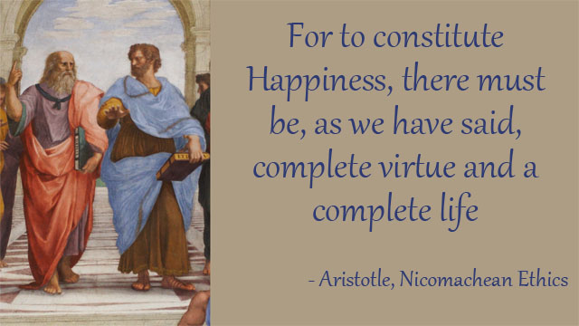

Aristotle’s Theory of Happiness
Refutation Two Chance
Arguments & Counter-Arguments

Debatable Issue: Aristotle’s theory of happiness is true.

This document contains a set of argumentative claims that can be made for each position, along with counter-arguments responding to each of them. This set can be used along with the Refutation Two-Chance Activity in one of two ways.

Either, you can give students on each time all or some of the relevant argumentative claims and counter-arguments against the other side’s claims. Or you can have students work to generate their own lists of argumentative claims and counter-arguments, using this set to prompt students or help them become “un-jammed” if they are struggling in that process. As part of this latter use of the set, you can upgrade the students’ lists of claims and counter-arguments following their own work on them by supplementing their lists with selections from this set.

Following the position statement, the argumentative claims will be flush left, while argumentative claims will be indented.

Affirmative Position:

Aristotle’s theory of happiness is true.

Since happiness is widely recognized as the highest good, it has to mean something much more than mere transient pleasure.

Not true, pleasure may be the highest good in life.

The feeling of pleasure is biologically verifiable and therefore the most scientific way of defining happiness.

Being able to delay gratification is one of the most important techniques for attaining real and lasting happiness.

This doesn’t prove that pleasure isn’t the best definition of happiness. Delaying gratification just means that people will experience more pleasure later on.

This is artificially imposing morality on to happiness. Delaying gratification may make a person more virtuous, it doesn’t necessarily make them happier.

Historical figures who have lived the most fulfilled lives have seemed to radiate something like Aristotle’s version of happiness.

There is no way to know if this is true or not. People may want to believe that the great persons of history were happier than the average person, but we don’t know whether this is so.

Actually, the happiest people in our society seem to be the less virtuous. Rich people with all of their desires fulfilled are typically very different than people like Mother Theresa or Gandhi. Look at people like our pop stars, rap stars, movie stars, or even Donald Trump.

Negative Position:

Aristotle’s theory of happiness is not true.

Aristotle cannot be correct since everyone has a different conception of happiness.

Truth doesn’t run for office; it’s not subject to a vote. The various ways that happiness is defined just means that various people are not thoughtful or enlightened about what true happiness is.

People have different conceptions of what they want – pleasure, power, material things, social status, etc. – but Aristotle would say that this simply means they want things other than real happiness.

Everyone experiences happiness as something transient, not something permanent.

Not true, people’s deepest feelings of happiness are when they reflect on a long period of time of virtuous living.

What the other side really means is that everyone experiences pleasure as something transient, and we agree with that. But pleasure is not happiness.

Aristotle’s theory is actually more subjective than the theory that happiness is related to pleasure, since there is no objective way to know whether someone has “lived in accordance with complete virtue” (4).

Being subjective or not scientifically provable doesn’t make Aristotle’s theory wrong. A lot of what philosophy studies for its truth value isn’t scientifically provable – for example, values, morality, how we know things, etc.

The whole point about happiness and the feeling of virtue is that it is personal. Aristotle is saying that only when we can judge ourselves as having lived virtuously do we experience the feeling of real happiness.

