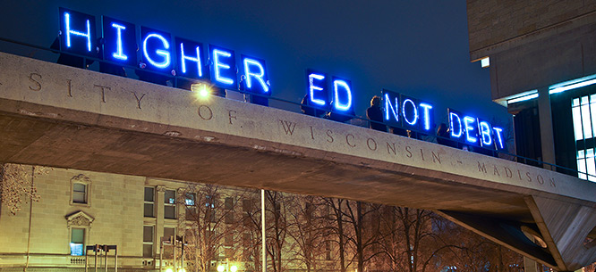

Free Public College
Refutation Two Chance
Arguments & Counter-Arguments

Debatable Issue: Should public college in the United States be free?

This document contains a set of argumentative claims that can be made for each position, along with counter-arguments responding to each of them. This set can be used along with the Refutation Two-Chance Activity in one of two ways.

Either, you can give students on each time all or some of the relevant argumentative claims and counter-arguments against the other side’s claims. Or you can have students work to generate their own lists of argumentative claims and counter-arguments, using this set to prompt students or help them become “un-jammed” if they are struggling in that process. As part of this latter use of the set, you can upgrade the students’ lists of claims and counter-arguments following their own work on them by supplementing their lists with selections from this set.

Following the position statement, the argumentative claims will be flush left, while argumentative claims will be significantly indented.

Affirmative Position:

Public college in the United States should be free.

College tuition costs have been growing very quickly in the past 20 years and public college today is unaffordable to most Americans.

Most Americans do not pay the college “sticker price,” and instead get offered financial packages that include aid, scholarships, loans, and work-study.

Calling college “unaffordable” is subjective: people pay for what they prioritize, and sending someone to college has always historically been a big financial sacrifice for families.

College has become a vehicle not for helping people move up the social ladder, but rather a cause of the ever-widening gap between the rich and the poor in this country.

There are many other causes of the divide between the rich and poor in the U.S. – such as crime, gangs, dysfunctional communities, failing schools – which means that free public college cannot by itself change the lack of social mobility.

If public college were free, the divide between rich and poor would continue through divides between “elite” and “common” colleges.

Student loan debt is becoming a major financial risk for our nation, and a major personal burden on young adults.

Getting a college education still massively repays students who have to take out loans over a lifetime of higher earnings that high school graduates, so for individuals loans are worth it.

The United States has not suffered any adverse economic consequences from having high total student loan debt these past 20 years or so.

More college graduates would be good for the economy overall, since they are more innovative, more entrepreneurial, and they earn much more during their lives.

Still, the cost to society of making public college free to everyone who wanted to attend would be massive.

It’s possible to have too many college graduates; the jobs the economy really needs today may not require a college degree.

Negative Position:

Public college in the United States should not be free.

Most students not attending college currently are not academically prepared for college and might flunk out if they went to a free public college.

Those who are less well prepared could take remedial college classes their first year or two, so that they filled in gaps in their college readiness.

The United States could, at the same time it made public college free, try to fix public high schools so that all or almost all graduating seniors were college ready.

Targeted aid to low-income college students would be much fairer than making college free to all students, even wealthy ones.

Targeted aid to low-income students is not politically sustainable; middle-class and more affluent voters will turn against it because they get no benefits from it.

There isn’t enough targeted aid being offered to low-income people to make college truly affordable.

Governmental control over public colleges – the likely result of the government paying everyone’s tuition – would significantly reduce their educational quality.

Governmental control of other sectors – for example, of the military, of the postal service, of food regulation – has seemed to work out well, without complaints about widespread quality of services.

Colleges would still compete and try to be innovative and better than other colleges in the same way they do now, even if the government was paying everyone’s tuition.

The experience of other nations, especially in Europe, shows that making public college free doesn’t have many significant benefits.

In at least some countries, free public college has increase enrollment percentages in
college.

European countries are different than the U.S. and have different histories and economies, so they two places cannot be compared.

