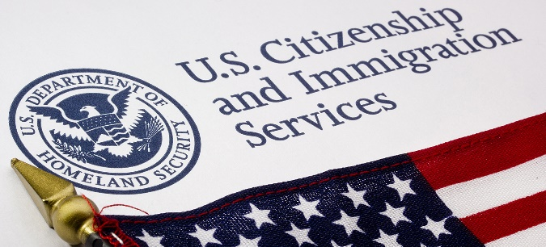

Immigration Micro-Macro Debates
Argumentative Claims

Debatable Issue: The United States should substantially reduce immigration.

Affirmative

Economic Impact Overall
Substantially reducing immigration would likely help the American economy overall.

High-Skilled Immigrants
The American economy does not need substantial numbers of high-skilled immigrants.

Humanitarianism
The United States has no humanitarian obligation to take in immigrants, including Syrian refugees.

Social Division/Diversity
Current levels of immigration to the U.S. are creating massive cultural division and a lack of social cohesion.

Terrorism
Reducing immigration is essential to preventing domestic terrorist attacks.

Wages/Unemployment
High levels of immigration lower workers' wages and increase unemployment for native-born Americans.
Negative

Economic Impact Overall
Substantially reducing immigration would harm the overall American economy.

High-Skilled Immigrants
A substantial number of high-skilled immigrant workers will fuel innovation and drive growth in the new economy.

Humanitarianism
The United States has an important humanitarian obligation to take in immigrants, including Syrian refugees.

Social Division/Diversity
Immigration helps build valuable cultural and social diversity in the United States.

Terrorism
Immigration is not directly related to the terrorist threat against the U.S.

Wages/Unemployment
Immigration has no negative effect on wages for American-born workers and likely increases employment.

