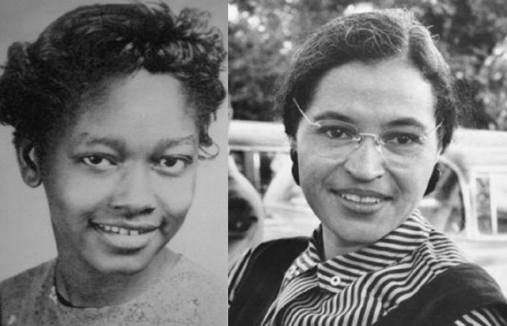
Claudette Colvin: Twice Toward Justice (2009)
Implementation Plan

The debatable issue for this project is:

Has Claudette Colvin been unfairly treated by history?

Day 1
Introduce the debatable issue
Screen author’s video on Twice Toward Justice
Orientation on the Argument-Based Dramatic Interpretations on Twice Toward Justice project
Create groups and identify Directors and Writers
Review selected events and incidents

Day 2
Finish review of selected events and incidents
Begin Writers’ Workshop: draft scripts of Argument-Based Dramatic Interpretations

Day 3
Writers’ Workshop: draft scripts of Argument-Based Dramatic Interpretations

Day 4
Finish Writers’ Workshop: draft scripts of Argument-Based Dramatic Interpretations
Submit scripts for feedback

Day 5
Distribute or deliver feedback to scripts of the troupes’ Argument-Based Dramatic Interpretations
Writers’ Workshop: revision of Argument-Based Dramatic Interpretations in response to feedback

Day 6
Writers’ Workshop: final revision of Argument-Based Dramatic Interpretations in response to feedback

Day 7
Actors’ Workshop: rehearsals of Argument-Based Dramatic Interpretations

Day 8
Actors’ Workshop: final rehearsals of Argument-Based Dramatic Interpretations

Day 9
First day of the Argument-Based Dramatic Interpretations of Twice Toward Justice

Day 10
Second and final day of the Argument-Based Dramatic Interpretations of Twice Toward Justice
Submit final draft of Argument-Based Dramatic Interpretations scripts
Reflective discussion of the debatable issue and Twice Toward Justice

