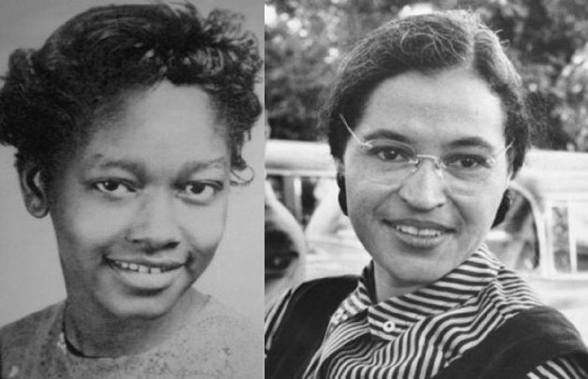
Claudette Colvin: Twice Toward Justice (2009)
Possible Argumentative Claims

The debatable issue for this project is:

Has Claudette Colvin been unfairly treated by history?

This is a set of possible argumentative claims on each side of the debatable issue. It can be adjusted depending on the argumentative claims that students generate through classroom writing and discussion.
Affirmative
Claudette Colvin was the pioneer of the Alabama bus boycotts.
Claudette Colvin demonstrated extraordinary personal courage and determination during the
bus boycott struggle.
Claudette Colvin was one of the four plaintiffs in the landmark Browder v. Gayle case, which
struck an important against the Jim Crow system of segregation.

Negative
The heroes of the Civil Rights Movement demonstrated leadership skills that Claudette
Colvin lacked.
Claudette Colvin's actions laid the groundwork for the actually important legal, political, and
social successes of the Civil Rights Movement.
Claudette Colvin had character flaws that disqualified her from being considered a more
prominent figure in the Civil Rights Movement.

