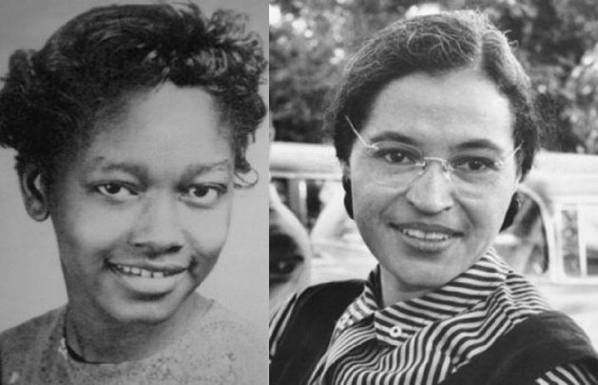
Claudette Colvin: Twice Toward Justice (2009)
Selected Events and Incidents

This is a set of events and incidents from Twice Toward Justice that can be used by troupes to guide their choice of what to write about in their scripts of dramatic interpretation of the book. Troupes are not limited to this set of events and incidents; they can choose their own events or incidents to write about, too.

Claudette’s early childhood in Pine Level, Alabama
(pp. 12 – 15)

Internalized racism expressed at Booker T. Washington High School in Montgomery
(pp.22-23)

Jeremiah Reeves’ arrest and conviction
(pp.23 – 26)

Geraldine Nesbitt’s consciousness-raising teaching
(pp. 26 – 29)

Claudette Colvin’s protest and arrest on a Montgomery bus – March 2, 1955
(pp. 31 – 37)

The mixed response at Booker T. Washington H.S. to Claudette’s Actions
(pp. 39 – 42)

The legal response that the NAACP helped mount to defend Claudette
(pp. 43 – 49)

The NAACP gravitates toward Rosa Parks and away from Claudette
(pp. 52 – 58)

Mary Louise Smith protests bus segregation in Montgomery
(pp. 58 – 61)

Rosa Parks is arrested for protesting bus segregation (December, 1955) and she becomes the figurehead of the movement
(pp. 63 – 71)

The Montgomery Improvement Association organizes the citywide bus boycott
(pp. 73 – 81)

The Browder v. Gayle lawsuit is organized and started, with Claudette a plaintiff
(pp. 81 – 85) This section includes description of Claudette’s having to juggle being a teenage mother with her role in the movement.

The case of Browder v. Gayle goes to trial in the federal district court in Alabama
(pp. 88 – 101)

The decision in Browder v. Gayle, and its aftermath
(pp. 103 – 111)

Claudette Colvin returns to Booker T. Washington on the 50th anniversary of the bus boycotts in Montgomery
(pp. 113 – 119)

