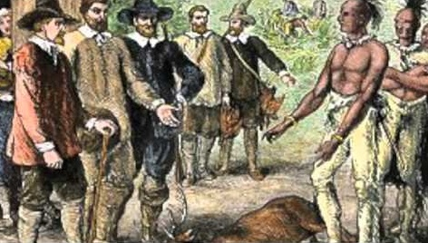

Blood on the River: James Town 1607
Character Questioning Form

The barristers who are responsible for questioning the characters on the witness stand should complete, and then present, the following argumentative form, one per witness.

Name of the witness: __________________________________
Argument(s) that you will try to support with this witness’s testimony:

First passage that your questions will focus on:

Second passage that your questions will focus on:

Questions [you can use constructs such as, “Didn’t you say that _________________,” “I’m going to read you a passage from Blood on the River and I’d like you to respond,” “When you did _________________, did you know that the natives would respond by ______________?” “Another character ____________ thought that you ________________. Why are they wrong?”]
1.

2.

3.

4.

Testimony that you hope to get in response to the questions:

