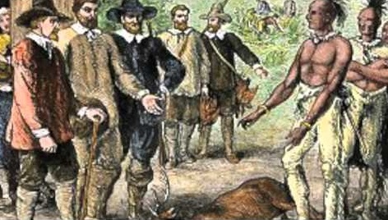

Blood on the River: James Town 1607
Character Testimony Prep Form

The character preparing to testify at trial should complete this form, and can use it as notes for their testimony at trial.

Name of the character: __________________________________
Your overall position on the debatable issue (it can be nuanced or ambiguous:

A passage to inform your testimony:

The argument that your character would make on the issue based on this passage [formulate a specific argumentative claim, and explain how the passage backs this claim up]:

A second passage to inform your testimony:

The argument that your character would make on the issue based on this passage:

A third passage to inform your testimony:

The argument that your character would make on the issue based on this passage:

