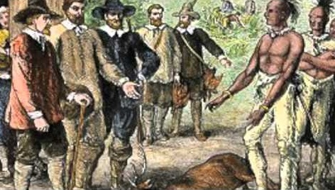

Blood on the River: James Town 1607
Opening Arguments Form

The barrister who is responsible for the Opening Arguments should complete, and then present, the following argumentative form.

Ladies and gentlemen of the jury – Chief Magistrate – may it please the Court to hear our opening arguments in today’s trial. We come before you today to convince you that the British aristocracy is/is not responsible for poisoning the English colonies’ relationship with the native population in America.
The first argument we will make to advance our position is that [formulate your claim]

Support for this claim can be found in the memoir Blood on the River, specifically in the passage [quote or paraphrase a passage from the text that supports the first argumentative claim]

This passage reveals that [provide reasoning that connects the passage to your claim, and that emphasizes the importance of this evidence to your claim and overall position]

The memoir also includes this important passage, which bears on our claim that ________
____________________________________________________________________________.
[Repeat your argumentative claim above, and below provide a second textual passage of evidence.]

Here, we see that [supply reasoning that connects evidence and claim, and that emphasizes the importance of the evidence to both the claim and the overall position.]

There is yet a second reason that we should/should not look to the British aristocracy as the primary cause of the hostility and fighting that has arisen between the native population and the English in the New World. It is that [formulate your 2nd claim]

For proof, we need look no farther than the place in Blood on the River in which young Mr. Collier states [include a passage that supports the claim]

The key to understanding this account is [provide reasoning that connects the passage to your claim, and that emphasizes the importance of this evidence to your claim and overall position]

This definitive text goes on to state that[provide a second textual passage of evidence]

The conclusion to be drawn from this passage is quite clear. [Supply reasoning that connects evidence and claim, and that emphasizes the importance of the evidence to both the claim and the overall position.]

We know that the barristers on the other side of this case are quite clever. They have argued/are likely to argue that [summarize the best argument for the other side – include the claim and a brief summary of the evidence and reasoning supporting it]

While that argument appears reasonable, it is important to remember, ladies and gentlemen of the jury, that [refute this argument, using evidence and reasoning]

What we ask you to focus on in this trial are these two important points [summarize your two argumentative claims] ____________________________________________________
________________________________________________________________________ and
____________________________________________________________________________.
We have proven them with the evidence we have cited from Blood on the River, and they will be further affirmed by the testimony you will hear from our character witnesses. May it please the court, we thank you.

