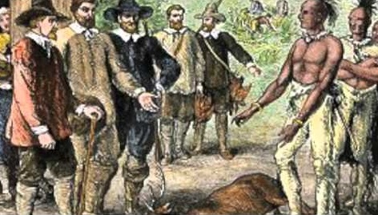

Blood on the River: James Town 1607
Possible Claims

The debatable issue for this project is:

Was the British aristocracy (i.e., those who ruled because of the family they were born into), according to Blood on the River, responsible for poisoning the colonies' relationship with the native population in America?

The following are possible claims that can be developed into full arguments or counter-arguments on both sides of the debatable issue.

Affirmative/British aristocracy was responsible for poisoning relations with the natives

The British gentlemen were lazy and greedy, which led them to try to exploit others.

The British aristocracy treated Chief Powhatan disrespectfully and unjustly.

The British gentlemen were so dishonest that they were even willing to kill innocent people to protect their self-serving lies.

The Virginia Company contracted the colonial mission to be concerned uppermost with the profits they could make from the Jamestown colony.

There was a legitimate possible alternative of living peacefully with the native population – in particular the Powhatans – in the New World.

The native population often helped, supported, and even saved the English colonists.

The cycle of violence between the Native Americans and the English colonists was put into motion by the mistreatment of the natives begun by the British gentlemen.

Negative/British aristocracy was not responsible for poisoning relations with the natives

The Jamestown colonists tried at first to trade with the native population, wanting to avoid
violence and domination.

The British gentlemen were actually less inclined to fight the Native Americans than the commoners were.

The Jamestown colonists were committed to spreading Christianity in the New World.

Native Americans were highly aggressive and used violence to try to expel the English from the New World.

There was no way around a struggle for power, and who was under whose control, between the British and the Native Americans.

The second wave of English colonists were racists who believed that the Native Americans were inferior and sub-human.

The Native American population had a highly developed system of warfare developed prior to the landing of the English colonists.

