Mass Incarceration Debates
Infographics

Brookings Institute, War on Drugs, Violent Crime, and Incarceration Rates: A Report. 2014

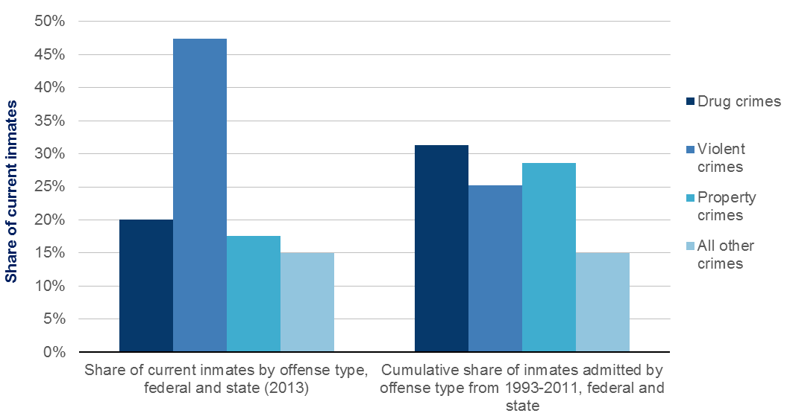
The Sentencing Project, Lifetime Likelihood of Imprisonment. 2008

