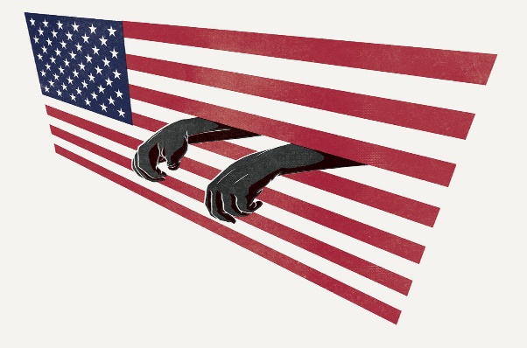

Mass Incarceration Debates
Media List

Debatable Issue

Is mass incarceration of African-Americans in the U.S. the moral equivalent of slavery?

Background/Both Sides (General)

http://www.slate.com/articles/arts/movies/2016/10/ava_duvernay_s_netflix_documentary_13th_reviewed.html
The Wikipedia entry on Mass Incarceration. It summarizes the phenomenon in the United States over the past 50 years, with the centerpiece definition: Mass Incarceration is "the criminal justice system but also to the larger web of laws, rules, policies, and customs that control those labeled criminals both in and out of prison.”

http://www.amnestyusa.org/our-work/issues/military-police-and-arms/police-and-human-rights/mass-incarceration-in-the-usa
Basic facts – and the human rights implications of those facts – produced by Amnesty International.
Mass Incarceration = Slavery

https://www.netflix.com/watch/80091741?trackId=13752289&tctx=0%2C0%2C375d0dc946f343db4aa55353015c0d474f886c68%3A3730488433930f72d27ce6c4953fb14735871341
Ava DuVernay’s 2016 documentary “13th,” takes a fact-based and close look at the American prison system and makes a historical argument that it has its racist roots in the Exceptions Clause of the 13th Amendment to the U.S. Constitution.

http://www.vogue.com/article/13th-ava-duvernay-review
An accessible, concise, and accurate summary of the documentary “13th”.

http://www.slate.com/articles/arts/movies/2016/10/ava_duvernay_s_netflix_documentary_13th_reviewed.html
A strong defense of the impact of the documentary “13th”.

https://www.youtube.com/watch?v=r4e_djVSag4
[Video, 6 mins] Video from the Equal Justice Initiative connecting the history of slavery in the United States and mass incarceration today.

https://www.youtube.com/watch?v=ISFTFoGSRjE
[Video, 4 mins] Federal mandatory minimum sentencing laws were harsh and racist and exploded the prison population.

http://www.huffingtonpost.com/entry/the-evolution-slavery-to-mass-incarceration_us_57f66820e4b087a29a54880f
Aristotle Jones, a civil rights lobbyist in Washington D.C., provides a short synopsis of the history of African-Americans, from 1619 to the present. He believes that the criminal justice system has re-institutionalized oppressive control over black people in this country.

http://www.aaihs.org/slavery-the-13th-amendment-and-mass-incarceration-a-response-to-patrick-rael/
Detailed analysis of the way that distinctions between chattel slavery and “prison slavery” break down – historically, legally, and currently – by Dennis Childs, Associate Professor at the University of California, San Diego.

http://www.huffingtonpost.com/angela-f-chan/america-never-abolished-slavery_b_6777420.html
The United States never abolished slavery. The 13th Amendment merely moved African-Americans from one institution – slavery – to another – the prison-industrial complex.

http://www.nydailynews.com/news/national/king-13th-amendment-didn-abolish-slavery-article-1.2801218
Mass incarceration is “slavery by another name.”

http://www.historyisaweapon.com/defcon1/gilmoreprisonslavery.html
An examination of the historical connections between the Abolitionist movement and the “abolish prisons” movement in the U.S.

https://www.democracynow.org/2015/3/4/michelle_alexander_roots_of_todays_crisis
[Video, 27 mins, with full transcript] Ohio State University law professor and author of The New Jim Crow, Michelle Alexander, fills out an analysis of the way that the criminal justice system has become a force of racial oppression in the U.S.

Mass Incarceration ≠ Slavery

http://www.aaihs.org/demystifying-the-13th-amendment-and-its-impact-on-mass-incarceration/
A professor of history at Bowdoin College argues that finding an equation between slavery and incarceration in the 13th Amendment to the U.S. Constitution is a misreading of history. The 13th Amendment was intended – and was understood at the time – to outlaw slavery, and to distinguish slavery from imprisonment of African-Americans, which it wanted explicitly not to deem illegal.

http://www.newyorker.com/magazine/2017/04/10/how-we-misunderstand-mass-incarceration
Mass incarceration is not purely a product of the Drug War or of racism against black people. Rather, it is a function of a conservative shift in the U.S. against violent crime, one that has over-empowered prosecutors.

http://reason.com/blog/2017/02/25/locked-in-john-pfaff-interview
The data, according to John Pfaff, Fordham University law professor, contradict “13th” and Michelle Alexander’s work on the criminal justice system. There isn’t a monolithic effort being made to imprison African-American men in this country.

http://digitalcommons.law.yale.edu/cgi/viewcontent.cgi?article=4599&context=fss_papers
Yale law professor James Forman gives a thorough-going rebuttal to Michelle Alexander’s thesis that the American prison system is enforcing “the New Jim Crow.”

http://www.americamagazine.org/arts-culture/2017/02/09/problem-mass-incarceration-more-complicated-we-thought
The DuVernay/Alexander narrative leave out the high rate of violent offenders in American prisons, and the fact that African-Americans themselves have been at the forefront of wanting to remove violent criminals from their streets.

http://www.nationalreview.com/article/440727/13th-documentary-politically-correct-dull-cowardly
The documentary “13th” omits important data about the improvement in conditions for African-Americans in the U.S. since the mid-19th century, and falsely implies an equivalency between figures like Trayvon Martin and civil rights icons such as Emit Till.

https://medium.com/@xenocryptsite/ava-duvernays-13th-and-documentary-as-advocacy-some-factual-issues-92e50b250d0
A critique of the factual basis for the several of the conclusions drawn in Ava DuVernay’s “13th.”

https://www.theatlantic.com/politics/archive/2016/04/ending-mass-incarceration/475563/
A review of the fact-based arguments against the Alexander/DuVernay account of mass incarceration – in particular, causes of mass incarceration other than systemic racism.

http://www.npr.org/2017/04/18/524569143/locking-up-our-own-details-the-mass-incarceration-of-black-men
NPR interview with James Forman, author of the 2017 book Locking Up Our Own, about the role that African-American law enforcement officials have played in the War on Drugs and, indirectly, in mass incarceration.

https://www.youtube.com/watch?v=S_m_qXMpLFo
[Video, 5 mins] History.org depicts the dehumanization of slave auctions.

https://www.youtube.com/watch?v=r9ieTEHCow4
[Video, 2 mins] Brief look at the horrific life of slaves in the 18th and 19th centuries.

