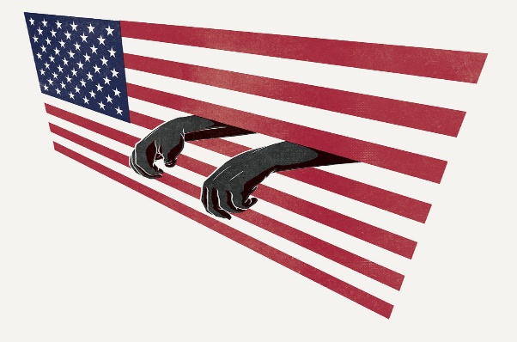

Mass Incarceration Debates
Possible Claims

Mass Incarceration = Slavery

The Thirteenth Amendment of the U.S. Constitution explicitly calls incarceration an acceptable form of slavery.

The American prison system has a severely disproportionate impact on African-Americans.

Prisons themselves are very similar to antebellum southern plantations.

The criminal justice system has institutionalized racism in this country.

The War on Drugs and Law and Order campaigns were designed to imprison and control black men.

The United States has such a long and deeply rooted history of racism that it isn’t reasonable to think that it has been eradicated.

Mass Incarceration ≠ Slavery

The Thirteenth Amendment does not equate slavery and incarceration; in fact, it does the opposite.

Mass incarceration is not the product of systemic racism.

African-Americans have been strong supporters of tough law enforcement in the United States.

Those equating mass incarceration to slavery are not basing their arguments on accurate data and evidence.

Slavery was horrific in ways that imprisonment isn’t.

The simple but undeniable distinction between incarceration and slavery is that slaves were innocent while inmates are convicted criminals.

