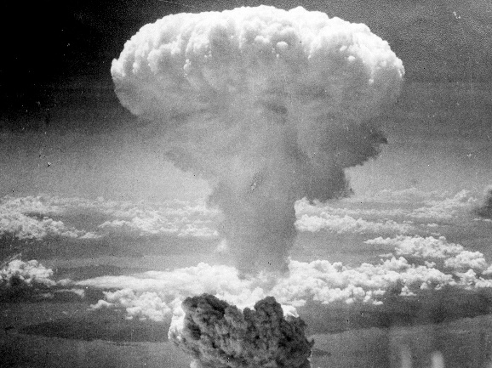
Use of Atomic Bombs in World War II
Media List

The debatable issue for this project is:

Was the United States justified in using atomic bombs against Japan in World War II?

Background/Both Sides

https://www.youtube.com/watch?v=3wxWNAM8Cso
[Video, 4 mins] A BBC video from 2017 uses testimony from Japanese persons (children at the time) who survived the atomic bombing of Hiroshima to re-enact the event from the time the Enola Gay flew over the city to the immediate aftermath of the bomb’s detonation.

https://www.youtube.com/watch?v=HIc3Hw6Nm0c
[Video, 4 mins] The Discovery Channel’s Test Tube News provides an overview of the factors leading to the U.S.’s decision to drop atomic bombs on Japan.

https://www.youtube.com/watch?v=W_IR50DIVKQ
[Video, 7 mins] British educational video company The Top Fives provides a historical summary of the run-up to the dropping of the atomic bomb, with an emphasis on the impact of the bombs on the Japanese victims.

http://www.ushistory.org/us/51g.asp
A solid, objective overview of President Truman’s decision to drop atomic bombs on Japan in WWII.

https://en.wikipedia.org/wiki/Debate_over_the_atomic_bombings_of_Hiroshima_and_Nagasaki
Wikipedia entry with a summary of the arguments on both sides of the issue and extensive references to sources.

https://legionmagazine.com/en/2014/09/face-to-face-was-the-dropping-of-the-atomic-bomb-on-japan-justified/
A short debate in Legion, a Canadian magazine on military history, between two military historians on the issue.

http://www.historyextra.com/feature/second-world-war/was-us-justified-dropping-atomic-bombs-hiroshima-and-nagasaki-during-second
On the BBC site HistoryExtra, a well-informed short debate is transcribed between two college students on the issue of the dropping of atomic bombs on Japan in World War II. The debate itself is less a source of evidence for arguments, and more a source of ideas for arguments and refutation.

Affirmative/The U.S. Was Justified in Using Atomic Bombs

https://www.youtube.com/watch?v=ZEO7pddV9fk
[Video, 4 mins] A BBC re-enactment of Truman’s deliberation over use of the atomic bomb. It includes Truman delivering an ultimatum to Japan: surrender or be decimated by a new weapon.

https://www.forbes.com/sites/henrymiller/2014/08/05/the-nuking-of-japan-was-a-military-and-moral-imperative/#1c78338b5269
Hoover Institute scholar supplies the evidence for the argument that dropping the atomic bombs on Japan ended the war and averted “Operation Downfall,” the land invasion of Japan that would have cost the lives of hundreds of thousands of American servicemen and millions of Japanese.

http://nationalinterest.org/feature/no-other-choice-why-truman-dropped-the-atomic-bomb-japan-13504
Article which responds to and attempts to refute what it considers to be the three strongest arguments against the use of the atomic bombs in WWII.

http://www.historyonthenet.com/authentichistory/1939-1945/1-war/4-Pacific/4-abombdecision/2-support/index.html
A U.S. history website collects evidence to support several of the most prominent arguments that have been made to justify use of the atomic bombs in WWII. The claims are fully formulated and followed by a presentation of fact-based evidence that has been used to support them. The site includes a full set of references used and cited.

http://www.pacificwar.org.au/AtomBomb_Japan.html
The Pacific War Historical Society, a non-profit organization made up mostly of Australian WWII historians, researchers, and students, summarizes the history of the use of atomic bombs in WWII in a way that emphasizes the justifications for President Truman’s decision.

Negative/The U.S. Was Not Justified in Using Atomic Bombs

http://theantimedia.org/dropping-the-bomb-on-hiroshima-and-nagasaki-was-never-justified/
Left-wing news outlet Antimedia lays out the case against the United States’ use of atomic bombs on Japan in WWII, including a variety of links to other sources opposing America’s use of atomic weapons.

http://www.colorado.edu/AmStudies/lewis/2010/atomicdec.htm
A University of Colorado compilation of American military leaders’ statements opposing the use of atomic weapons against Japan, each with their own citation.

http://www.newstatesman.com/blogs/mehdi-hasan/2010/08/hiroshima-war-japanese
America’s use of atomic bombs on Japan in WWII was a war crime because it killed hundreds of thousands of innocent Japanese citizens for no good reason. There were several viable alternatives to the use of atomic weapons that would not have killed nearly so many people, especially since Japan was near surrendering by the middle of the summer, 1945.

http://www.historyonthenet.com/authentichistory/1939-1945/1-war/4-Pacific/4-abombdecision/3-against/index.html
A U.S. history website collects evidence to support several of the most prominent arguments that have been made to against the use of the atomic bombs in WWII. The claims are fully formulated and followed by a presentation of fact-based evidence that has been used to support them. The site includes a full set of references used and cited.

http://www.doug-long.com/index.htm
Independent historian Doug Long’s website on the use of atomic weapons on Japan in WWII. Long concludes that their use was not justified, though for him it’s a fairly close call, and he is extremely steeped in the arguments of the other side. His website includes a wealth of useful material, including a large bibliography of books and other works on this issue, as well as transcribed and extended debates on the issue with other historians.

