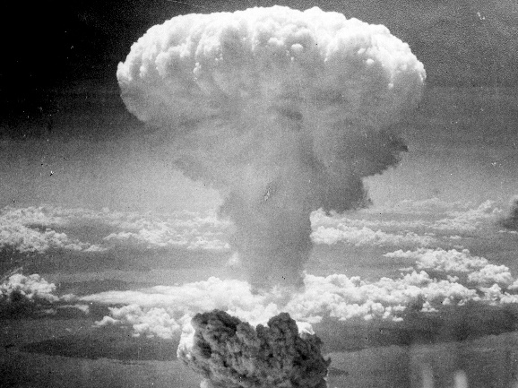
Use of Atomic Bombs in World War II
Primary Documents

The debatable issue for this project is:

Was the United States justified in using atomic bombs against Japan in World War II?

These primary documents should be used as evidence to support arguments you build and make in this project.

The U.S. Was Justified in Using Atomic Bombs

Secretary of War Henry Stimson, Memoirs, 1947
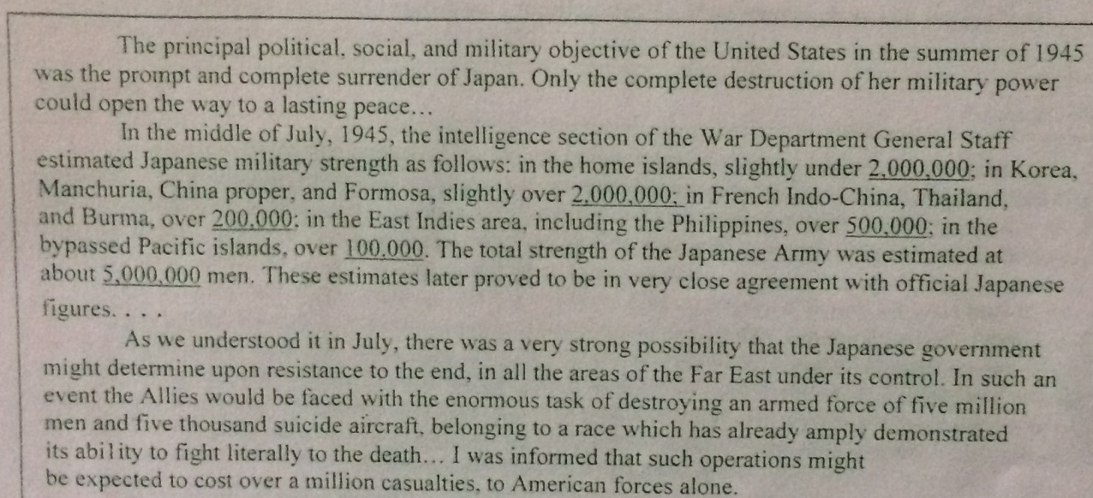
British Prime Minister Winston Churchill, Interview [re his learning that the U.S. completed the atomic bomb in July, 1945] with the British Broadcasting Corporation, 1953
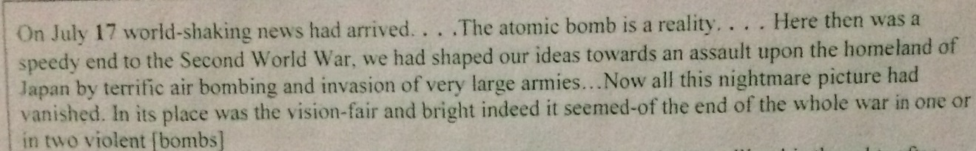

President Harry S. Truman, Radio Address, August 10, 1945
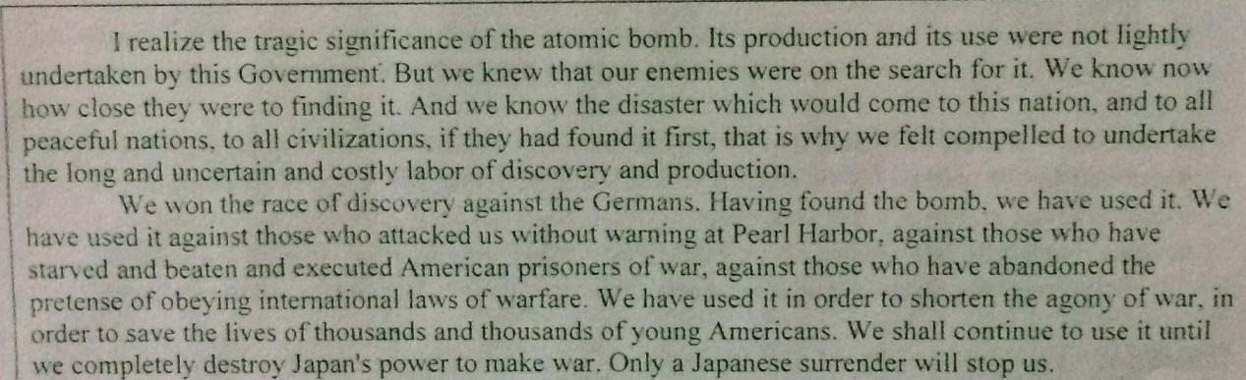
The U.S. Was Not Justified in Using Atomic Bombs

General H.S. Arnold, Commander of the Air Force in World War II, Memoirs, 1949
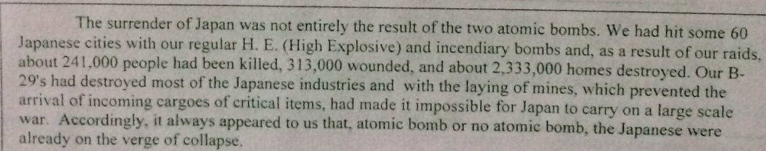

Leo Szilard, nuclear physicist, recollecting a 1945 meeting between U.S. military leader James Byrnes and
nuclear physicists working on the bomb
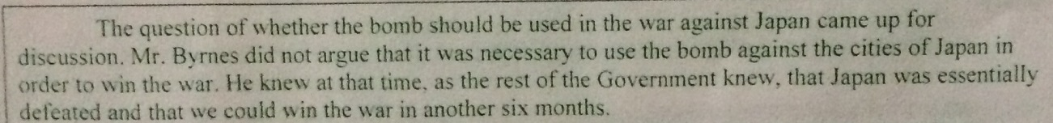

Notes from a meeting of the Joint Chiefs of Staff, June 20, 1945
