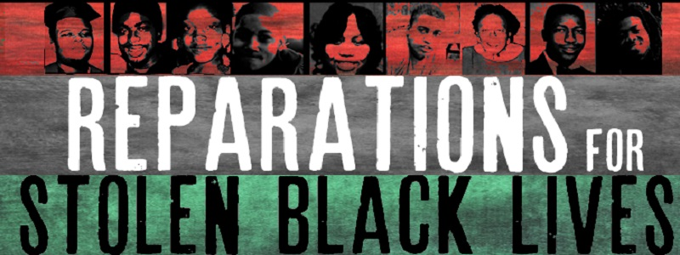

Reparations
Infographics

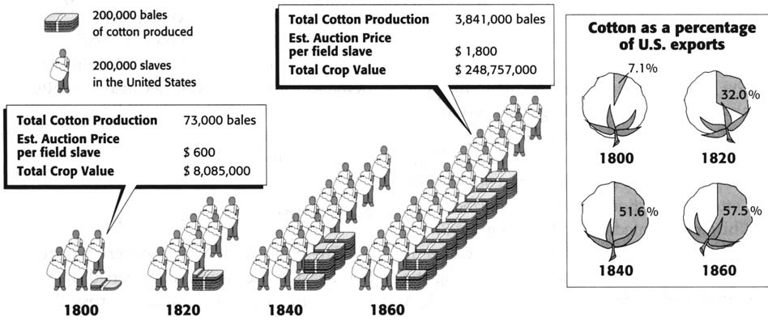
American Slavery: An Introduction, Basic Books, 2003

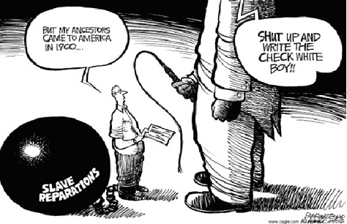

Orlando Sentinel, July 21, 2004

