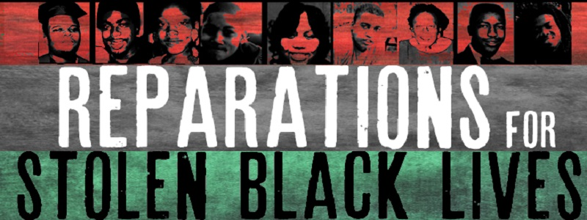

Reparations
Possible Claims

These are possible argumentative claims that can be made on either side of the debatable issue on reparations.

The U.S. Should Pay Reparations

The history of American racism is one of systematic exploitation of black people by official governmental policy, including and even after slavery.

African-Americans are currently suffering from vast levels of economic inequality relative to whites.

There are important historical precedents for providing reparations to African-Americans.

Historical wealth in the U.S. was created to a very large extent by slaves.

The U.S. Should Not Pay Reparations

Reparations will not be effective in improving the longer-term economic conditions of African-
Americans.

Reparations are unjust because they treat blacks and whites as a group rather than treating each person as an individual.

Reparations are extremely divisive and therefore would not be politically sustainable.

Reparations would be a serious distraction from programs that would do more to help African- Americans.

