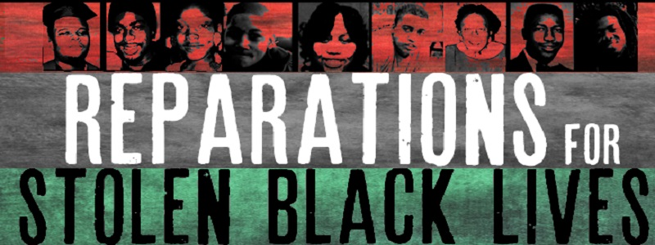

Reparations
Possible Claims & Counter-Claims

These are possible argumentative claims and counter-claims that can be made on either side of the debatable issue on reparations. Each possible claim is followed by two possible counter-claims, indented.

The U.S. Should Pay Reparations

The history of American racism is one of systematic exploitation of black people by official governmental policy, including and even after slavery.

The key point here is that this is historical, not current, exploitation, and white people today cannot be punished for crimes done by previous generations.

There have also been a lot of governmental programs that have been and are specifically targeted to help support and raise up African-Americans.

African-Americans are currently suffering from vast levels of economic inequality relative to whites.

African-Americans’ overall economic status has been improving, even without reparations.

Sustained economic improvement comes from building up skills and habits, not from being given money from the government.

There are important historical precedents for providing reparations to African-Americans.

These precedents have important differences from the call for reparations for American racism.

The precedent that giving reparations for racism would lead to endless policies to make up
for past injustices.

Historical wealth in the U.S. was created to a very large extent by slaves.

This is, again, historical, not current, and can only mean that generations long since dead owed African-Americans (also long since dead) a lot of money.

The creation of American wealth in the present and even recent past has very little to do with racism, it is much more a product of technology, natural resources, human capital, and trade.

The U.S. Should Not Pay Reparations

Reparations will not be effective in improving the longer-term economic conditions of African-
Americans.

It would certainly be a start, especially if reparations include (as Ta-Nehisi Coates advocates) support for programs (such as pre-K and quality daycare) that would especially help African-Americans.

There is actually a lot of evidence that shows that direct financial grants to low-income people have a big positive impact.

Reparations are unjust because they treat blacks and whites as a group rather than treating each person as an individual.

But racism itself has treated all black people as a group, which means that the solution to racism will have to be group-oriented, too.

Reparations can make exceptions for African-Americans who are financially or socially very successful already.

Reparations are extremely divisive and therefore would not be politically sustainable.

Even if reparations are not popular, they are morally required.

American institutions should show leadership on this issue, and not follow public opinion polls.

Reparations would be a serious distraction from programs that would do more to help African- Americans.

Social programs are fully compatible with reparations; we should have both.

Only reparations directly target the historical legacy of official racism that has exploited and dehumanized African-Americans.

