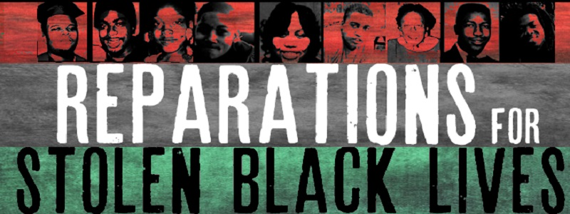

Reparations
Media List

Debatable Issue

Should the United States pay reparations for slavery and the historical legacy of anti- black racism?

Background/Both Sides (General)

http://crooksandliars.com/2015/02/shelby-steele-and-ta-nehisi-coates-debate
[Video, 6 mins] Shelby Steele and Ta-Nahesi Coates debate reparations on ABC News’ This Week.

http://www.pbs.org/wgbh/point-taken/should-us-pay-reparations-black-americans/#watch
[Video, 25 mins] An excellent PBS Point Taken debate on reparations. The webpage includes a graph with cited evidence on both sides of the debate, in addition to “dive deeper” sources.

https://academic.udayton.edu/race/02rights/repara29c.htm
Alfred Brophy lays out some of the most powerful arguments against reparations and some of the responses to and questions asked of those arguments, in the DePaul University Law Review (2004).

The U.S. Should Pay Reparations

https://www.youtube.com/watch?v=Kk63XQwix28
[Video, 14 mins] In 2014, MSNBC host Chris Hayes interviews Ta-Nehisi Coates on his essay on reparations.

http://billmoyers.com/episode/facing-the-truth-the-case-for-reparations/
[Video, 24 mins] Bill Moyers sits down with Ta-Nehisi Coates in 2014 to discuss his essay on reparations.

https://www.theatlantic.com/magazine/archive/2014/06/the-case-for-reparations/361631/
African-American author and public intellectual Ta-Nehisi Coates makes the contemporary classic case for reparations. This 2014 article re-introduced this issue as a public debate in the U.S.

http://cultureandyouth.org/criminal-justice/articles-criminal-justice/review-the-case-for-reparations/
The youth education organization Culture and Youth summarizes Ta-Nehisi Coates’ long article on reparations, and includes discussion questions on the article.

http://www.randallrobinson.com/excerpt_debt.html
An excerpt from The Debt: What America Owes to Blacks, a book by Randall Robinson, a law professor at Penn State University. Robinson’s book is a precursor to Ta-Nahesi Coates’ essay.

http://www.truth-out.org/news/item/41622-ta-nehisi-coates-on-how-cities-and-municipalities-are-winning-reparations-for-slavery-at-local-levels
An August 2017, brief interview with Ta-Nehisi Coates on Democracy Now! Coates talks briefly about the racist demonstrations in Charlottesville and about his practical vision for reparations, that they will come about through local lawsuits citing specific damages, rather than through a single national policy, program, or judgment.

http://www.nybooks.com/articles/1969/07/10/black-manifesto/
The Black National Economic Conference’s Black Manifesto (1969) lays out the moral demands for reparations that come out of the history of racial oppression in this country.

The U.S. Should Not Pay Reparations

http://www.nationalreview.com/article/378737/case-against-reparations-kevin-d-williamson
The conservative National Review offers a rebuttal to Ta-Nehisi Coates’s essay on reparations.

https://www.theatlantic.com/business/archive/2014/06/the-impossibility-of-reparations/372041/
Former George W. Bush speechwriter and author David Frum argues against reparations as entirely impractical and unworkable.

http://www.thecritique.com/articles/ta-nehisi-coates-case-for-reparations-spiritual-awakening/
Professor of philosophy at the State University of New York (Fredonia) Stephen Kershnar critiques Coates’s call for reparations on a number of philosophical grounds.

https://www.forbes.com/sites/kylesmith/2014/06/19/why-reparations-wouldnt-work/#5de917ec5394
Forbes article says that reparations would fail because research shows that people who are suddenly given a large amount of money do not stay wealthier or happier.

https://www.jacobinmag.com/2016/02/ta-nehisi-coates-case-for-reparations-bernie-sanders-racism/
Jacobin Magazine critiques Ta-Nehisi Coates’ essay on reparations from the political left. It argues that instead of lumping affluent and poor blacks together in a reparations policy, the U.S. should address class and income disparity. This policy, history suggests, would have the greatest positive impact on the millions of impoverished and low-income African-Americans.

http://www.huffingtonpost.com/leonce-gaiter/are-tanehisi-coates-and-b_b_9051138.html
Short article from essayist Leonce Galter arguing that before African-Americans can push whites to accept reparations they need to be far more aware and educated about the history of racism in this country.

