School Choice
Infographics

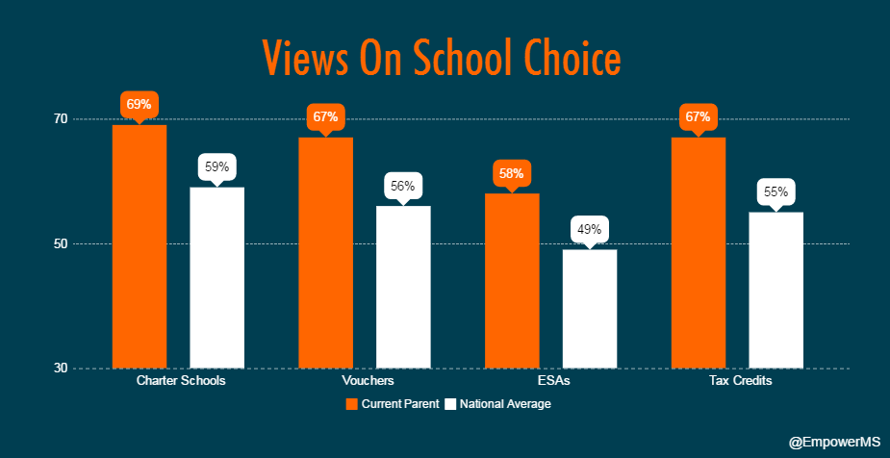
Brett Kittredge, EdChoice, October 27, 2016

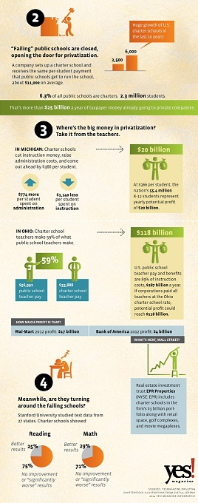
Yes! Magazine, 2014.

