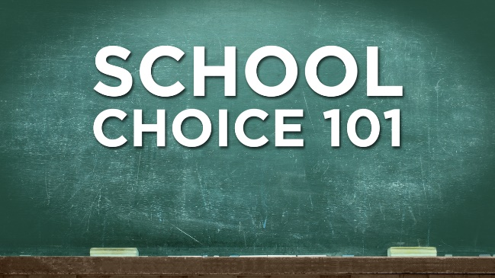

School Choice
Media List

Debatable Issue:

Does school choice improve public education?

Background/Both Sides (General)

https://www.youtube.com/watch?v=uXlJ3ezSZpg
[Video, 10 mins] Independent education advocacy group The School Project produced this 2015 documentary called “UnChartered Territory.” It examines the historical origins of charter schools and the rise of charter schools in Chicago over the past ten years. It features testimonials from charter school leaders, and opponents of charter schools, though it is not research- or fact-heavy and it refrains from drawing any conclusions.

https://www.youtube.com/watch?v=vlcO5JUbBtY
[Video, 5 mins] PBS NewsHour report on the new Secretary of Education Betsy DeVos and President Trump’s commitment to promoting school choice.

https://www.youtube.com/watch?v=_w1b-8FV2qI
[Video, 3 mins] CBS News video from 2008 takes a look at charter schools (in Chicago) and makes arguments on both sides of the question as to whether they are improving student academic achievement over public schools.

https://www.youtube.com/watch?v=FNNcZEOUX50
[Video, 9 mins] Serious-minded Reason TV interviews the Fordham Institute’s vice-president Nick Pondiscio, an expert on charter schools and a founder of Democracy Prep, a charter school in Harlem, New York City. Pondiscio acknowledges that charter schools “weed out” difficult students, but he argues that this makes charters simply “poor man’s” private academies, which should be considered a good thing.

https://www.youtube.com/watch?v=ye83Fvtn7LE
[Video, 90 mins] An Intelligence Squared debate on the question, Are charter schools overrated?

http://www.npr.org/sections/ed/2017/05/21/522051355/why-its-so-hard-to-know-whether-school-choice-is-working
NPR report that the data on school choice is complicated and in fact somewhat murky because of both “selection bias” – an unrepresentative group of students selects or is selected by charter and private schools – and by an “exclusion effect,” whereby charters and private schools can push out less desirable students. With these important caveats, the report finds some benefit to charters, though only in urban schools, and little benefit if any to private schools.

School Choice Improves Public Education

https://www.youtube.com/watch?v=G9d4PG2lLQQ
[Video, 2 mins] Short 2015 video from the National Alliance of Public Charter Schools featuring teachers and students making concise points in favor of the benefits of charter schools.

https://www.youtube.com/watch?v=AMbR-jATgWs
[Video, 4 mins] 2014 American Enterprise Institute video explaining how and why a free market system of education is better for the average student, teacher, and parent, and could revolutionize the American education system.

https://www.youtube.com/watch?v=01JPPKGSHAw
[Video, 3 mins] CNN report from 2015 covers what it touts as the success story of the New Orleans school system, which became fully charterized after Hurricane Katrina. The report acknowledges that there are critics in New Orleans, but presents data that overrides or refutes their concerns.

https://www.youtube.com/watch?v=PyBUlSrIOh4
[Video, 8 mins] A 2016 PBS NewsHour report on the charter vs. district school debate in Memphis, and in particular the way that it is dividing African-Americans. It is ostensibly an even-handed look at the two sides, but the weight of the evidence it presents favors charters. The thesis of the piece can be summarized by its line: low-income African-American families in Memphis are voting with their feet in favor of charters.

http://www.pbs.org/wgbh/pages/frontline/shows/vouchers/choice/choice.html
Caroline Hoxby, a professor of economics at Harvard University, lays out the connection between classic economic theory and the arguments in favor of choice in education.

https://www.cato.org/blog/how-school-choice-improves-public-schools
The Cato Institute makes the point that school choice introduces a strong incentive to public school districts to better respond to student and parent needs so that they retain students in their system.

https://www.brookings.edu/wp-content/uploads/2016/10/ccf_20161021segregation_version-10_211.pdf
Brookings Institute report that looks at the impact of charter schools on school segregation (it finds that segregation is already very high, though charters may make it worse) also examines data on academic achievement. It finds that strict “no excuses” charter schools produce significantly higher student achievement among low-income urban students than do closely comparable district public schools.

http://www.nytimes.com/2011/12/12/opinion/does-school-choice-improve-education.html?mcubz=1
Chairman of the Black Alliance for Educational Options states that if charters help some under-served students do better, they should be embraced.

http://www.heritage.org/education/report/the-value-parental-choice-education-look-the-research
Heritage Foundation review of some recent research that shows positive outcomes for special needs students and for parental involvement from school choice programs in Florida and Wisconsin. Also, public school districts improve when faced with this competition.

http://www.edchoice.org/wp-content/uploads/2016/05/A-Win-Win-Solution-The-Empirical-Evidence-on-School-Choice.pdf
A 2016 report from the Friedman Foundation for Education Choice that purports to summarize a series of recent studies that conclude that school choice improves public education in a wide variety of ways.

School Choice Does Not Improve Public Education

https://www.youtube.com/watch?v=5BfoWt1LeBg
[Video, 24 mins] On the April 15, 2014 edition of Moyers & Company, Bill Moyers interviews education historian Diane Ravitch on charter schools. Ravitch is severely skeptical of the value of charter schools. She sees private profiteers behind charters and the full range of moves to privatize public education. One point Ravitch makes is that public schools are NOT failing, despite the public mythology to the contrary. Charters are harmful to democracy and not good for students, she believes. Moyers, too, begins the broadcast with clippings on the pursuit of profit by companies increasingly working in the public sector.

https://www.youtube.com/watch?v=HJmNzx8CXVE
[Video, 4 mins] Sam Seder of the Majority Report cites two studies that purport to show that students at charter schools in the aggregate do no better on reading or math testing than do students at district-run schools. Charter schools are only about privatizing public education, since they are privately managed and operated.

https://www.youtube.com/watch?v=2BWVInIJ86A
[Video, 26 mins] Journalist Chris Hedges interviews Diane Ravitch, education historian at New York University. He and Diane Ravitch lay out a very developed case in favor of traditional public schools and opposed to charter schools. The interview is preceded by a set of facts that undermine the arguments for charter schools.

https://www.usnews.com/news/best-countries/articles/2017-01-30/little-global-evidence-suggests-school-choice-helps-performance
Professor of economics and education at Columbia University Henry Levin reviews data from the Program for International Student Assessment (PISA) shows that school choice initiatives are NOT leading to improved academic performance in countries around the world.

http://www.nytimes.com/2011/12/05/opinion/why-school-choice-fails.html
Author Natalie Hopkinson describes the negative consequences on local neighborhood schools when investing in charters is the priority.

https://www.gse.harvard.edu/news/uk/16/11/problem-school-choice
Harvard economist Joshua Goodman draws distinctions between the education sector and other “markets” that make competition much less effective in schools.

https://www.washingtonpost.com/local/education/naacp-school-choice-is-not-the-answer-to-improving-education-for-black-students/2017/07/26/7b4edcf0-721c-11e7-9eac-d56bd5568db8_story.html?utm_term=.24ed6f6439f4
The NAACP comes out against increasing school choice and in favor of tighter regulations over current charter schools.

https://news.vice.com/story/school-choice-detroit-betsy-devos
Vice News takes a close look at the consequences of turning the Detroit school system into a largely charter network and concludes that the children of Detroit have been betrayed.

https://www.currentaffairs.org/2016/11/why-is-the-decimation-of-public-schools-a-bad-thing
Current Affairs magazine opposes school choice as a move toward the privatization of public education. Public education treats children, especially poor children who are less likely to have families who can fully protect them, as an end in themselves rather than a means to make money or in some other way profit. A fully public system of education is essential to our democracy.

