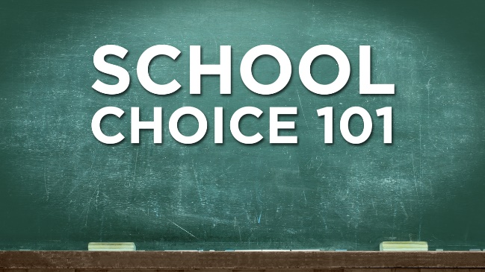

School Choice
Possible Claims and Counter-Claims

These are possible argumentative claims and counter-claims that can be made on either side of the debatable issue on school choice.

School Choice Improves Public Education

Charter schools have improved student academic achievement over traditional public schools, especially in urban schools.

This isn’t true: many studies, including international studies, show that charter schools either do not improve educational outcomes or even make them worse.

Where charter schools have out-performed public schools, it is only because they are selective in what students they accept and what students they retain.

School choice makes public schools better by imposing a strong incentive on them to compete to attract students.

Actually, school choice drains financial resources away from neighborhood schools and makes them dumping grounds for students the charter schools don’t want.

Countries with the best public schools strongly support equitable neighborhood schools, not disruptive competition.

Parents prefer charter schools, which strongly suggests that they are better for kids.

Charter schools spend more money marketing themselves and are appealing because they are “the new thing.”

This is a false comparison: parents would support better supported, improved neighborhood schools, if we made that commitment.

School districts are bloated and inefficient, and they stifle creativity.

Charter schools have administrators too, and in fact spend a higher percentage of their budgets outside the classroom.

These charges are outdated; school districts have become much more efficient and innovative.

School Choice Does Not Improve Public Education

Data does not show that school choice improves student achievement.

There is a strong consensus of studies that shows that school choice improves student achievement.

Evidence for the other side is based primarily on international comparisons, which are hard to make because of the differences between these countries and the U.S.

Charters are a significant step toward the privatization of public education, which threatens
American democracy.

Charters are funded entirely by the public and are regulated and held accountable by local governments.

Charter schools actually promote American democracy by giving all parents choice in the school that they wish to send their children.

School choice leads to more racially segregated schools.

Schools are already highly segregated; traditional public schools do not successfully integrate education.

If this is true it is because of the preference of parents who send their students to these schools.

Charter schools take funds out of the classroom and under-value teachers.

Charter schools should be praised for being more efficient with their funds. They get better results with less money.

Traditional public schools, have paid over-sized contracts to teachers who are not always effective in the classroom.

