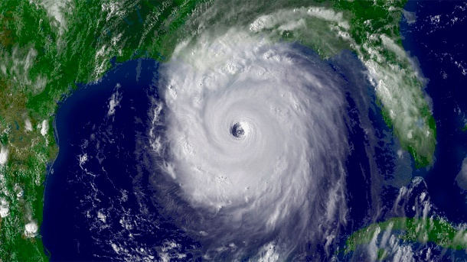

Hurricanes: Crisis and Critique
Argument-Based Questions on Informational Texts

Directions
Students should be put in pairs to work on this activity. Each student should respond to the questions independently. Then, when both students have completed the questions (or when everyone has been given the time allotted to complete the questions), they should share their responses with each other, discussing in particular any differences in response. After each brief discussion, students should take a moment to note how that discussion would change their response, if at all. Students should be encouraged to think meta-cognitively about their own reasoning and support for their responses and how they compare with that presented by their partner. It is a sign of thoughtfulness to note revised responses. The activity should conclude with pairs sharing out their (a) strongest responses, and (b) summaries of discussion that generated the most revision in one or both of their responses.

Note that for each article, the questions are preceded by a debatable issue that the article directly or implicitly addresses. The teacher should review these debatable issues before the activity begins, to be sure that all students understand them and their terms.

Article: Sheila Dewan and John Schwartz, “How Does Harvey Compare with Hurricane Katrina? Here’s What We Know,” New York Times, August 31, 2017

Debatable Issue: Were Hurricane Harvey (2017) and Hurricane Katrina (2005) more similar than
dissimilar?

1. Do the most directly affected two cities in the two storms suggest that they were more similar or dissimilar? What are the most important facts here?

--------------------------------------------------------------------------------------------------------------------------------------
Revision resulting from discussion:

2. Do you know anything either about how the two hurricanes affected regions outside these two major cities, or anything more about the cities that is not in the article, that would contradict the argument above (in your response to question 1)?

--------------------------------------------------------------------------------------------------------------------------------------
Revision resulting from discussion:

3. If you combine the “Storms” and “Rainfall” sections (which would seem logical to do), there seems to be evidence to support either side of the debatable question. Identify two data points to support each position from these two sections.

--------------------------------------------------------------------------------------------------------------------------------------
Revision resulting from discussion:

4. Formulate an argumentative claim to support one side or the other based on the “Deaths and Damage” section of the article, and cite four pieces of data from the section to support this claim.

--------------------------------------------------------------------------------------------------------------------------------------
Revision resulting from discussion:

5. On the surface the sections “Evacuation” and “Assistance” seem to support the position that Hurricane Katrina and Hurricane Harvey were more dissimilar than similar. Counter that interpretation, however, interpreting the evidence in these sections in the other direction.

--------------------------------------------------------------------------------------------------------------------------------------
Revision resulting from discussion:

6. What do you think about “The Takeaways,” according to the article? Are they consistent with what you know and have learned about the two hurricanes? What position do they support and why?

--------------------------------------------------------------------------------------------------------------------------------------
Revision resulting from discussion:

Article: Richard Fausset, “In Texas, Distrust of Washington Collides with Need for Federal Aid,” New York Times, September 4, 2017

Debatable Issue: Has Hurricane Harvey shown Texans to be hypocritical in their attitude toward the
federal government?

1. Summarize the predominant ideological view of the federal government, and include two pieces of evidence from the article as part of your summary. Also, explain what makes this view “ideological” (i.e., part of an overall set of political convictions and viewpoints).

--------------------------------------------------------------------------------------------------------------------------------------
Revision resulting from discussion:

2. Why do critics like Governor Chris Christie (R-NJ) call out people like Senator Ted Cruz (R-TX), who are now advocating for generous federal aid to victims of Hurricane Harvey, for hypocrisy?

--------------------------------------------------------------------------------------------------------------------------------------
Revision resulting from discussion:

3. Summarize in some detail how libertarian commentator Michael Berry has attempted to refute Christie’s charge of hypocrisy. Do you find Berry’s refutation persuasive? Why or why not?

--------------------------------------------------------------------------------------------------------------------------------------
Revision resulting from discussion:

4. Some might argue that Texas Governor Greg Abbott’s decision not to tap into his state’s $10 billion “rainy day fund” and instead ask for federal support is an example of hypocrisy. How do you think Gov. Abbott would respond to that charge?

--------------------------------------------------------------------------------------------------------------------------------------
Revision resulting from discussion:

5. In the middle of the article, a paragraph begins, “Despite the pervasive anti-Washington rhetoric, Texas relies heavily on the federal government.” What are the two most important data points to support that claim, in that and the following paragraph? Explain why you selected these two.

--------------------------------------------------------------------------------------------------------------------------------------
Revision resulting from discussion:

6. What specific argument might be made – based on the article’s discussion of Texas’s anti-government sensibility being bipartisan – that Harvey does NOT reveal any hypocrisy among Texans?

--------------------------------------------------------------------------------------------------------------------------------------
Revision resulting from discussion:

7. Jim Hightower sums up the competing American values at the heart of the debate taking place in Texas over the role of the federal government in Harvey and its aftermath. What are those competing values, and how do Senator Bryan Hughes and Reverend Joe Miller represent the two opposing sides of this internal values-divide?

--------------------------------------------------------------------------------------------------------------------------------------
Revision resulting from discussion:

