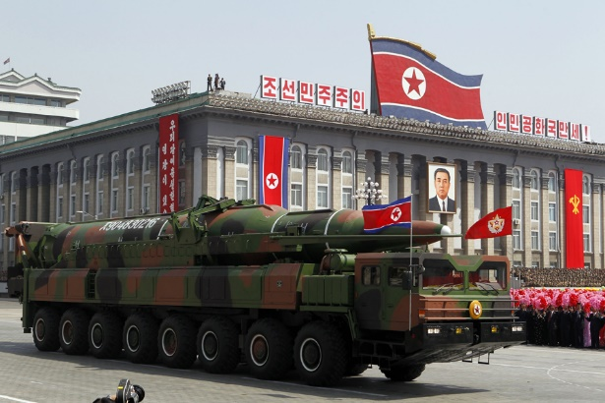

North Korean Nuclear Weapons
Media List

Debatable Issue

Should the United States contain and deter North Korea as a nuclear power, or should it use whatever means necessary, including military force if needed, to eliminate its ability to threaten the U.S. with nuclear weapons?

Background/Both Sides (General)

https://www.youtube.com/watch?v=NwbYpdGpx8U
[Video, 7 mins] A very solid background from Vox.com on the science and technology, and military and political implications, of North Korea’s acquisition of nuclear weapons. The video demonstrates in detail how dangerous North Korea’s nuclear weapons are, not only to the U.S. but to American allies in Southeast Asia.

https://www.youtube.com/watch?v=XcRC6GLx_T8
[Video, 6 mins] A look at the reasons North Korea has acquired nuclear weapons, and a review of five options for a U.S. response, by educational video company The Daily Conversation. All five options are bad ones, the video concludes.

https://www.youtube.com/watch?v=nnp_VB4Ef0Q
[Video, 2 mins] NBC News video gives a short timeline of the history of North Korea’s acquisition of nuclear weapons and their testing of missiles, most recently of inter-continental ballistic missiles (ICBMs) that can reach American territory.

https://www.youtube.com/watch?v=cbjNYgdM5kw
[Video, 4 mins] Atlantic Magazine video providing an overview of the current crisis in North Korea over its development of nuclear weapons that it now claims it can attach to inter-continental ballistic missiles (ICBMs) capable of reaching the U.S. mainland, possibly as far away as Chicago. The video begins with a very brief summary of Korean history since the middle of the 20th century. It concludes by seeming to favor the “containment and deterrence” option.

https://www.youtube.com/watch?v=XPU43GSTI9E
[Video, 9 mins] Extensive review of North Korea’s military, and its military threat, by education video makers Second Thought (April, 2017).

https://www.nytimes.com/2017/08/20/world/asia/north-korea-war-trump.html
The Trump administration is actively considering a “preventive war” against North Korea, in order to strip it of the capacity to launch nuclear weapons that can reach the United States.

https://www.usatoday.com/story/opinion/2017/07/06/north-korea-nuke-deterrence-works-editorials-debates/103483372/
Several experts talking about what to do in the face of North Korea’s having tested inter-continental ballistic missiles (ICBMs) successfully.

http://www.newsweek.com/north-korea-john-mccain-democrats-and-experts-condemn-donald-trumps-threats-648356
A variety of responses to President Trump’s statement that North Korea will be met with “fire and fury like the world has never seen” if they continue to make threats against the United States.

North Korean Nukes Should Be Accepted, Contained, and Deterred

https://www.theatlantic.com/magazine/archive/2017/07/the-worst-problem-on-earth/528717/
Thorough look at the current nuclear weapons crisis in North Korea, isolating four response options for the United States: military first strike, militarily taking out North Korea’s missile sites, decapitation of the Kim regime, and acceptance and deterrence. Atlantic Magazine concludes that the fourth option – acceptance and deterrence – carries the least risk of catastrophe.

https://www.nytimes.com/2017/08/10/opinion/susan-rice-trump-north-korea.html?ref=opinion&_r=2
Former National Security Adviser to President Obama Susan Rice lays out a case for containing and deterring a North Korea with nuclear weapons.

http://www.libertylawsite.org/2017/07/10/with-north-korea-deterrence-remains-the-best-option/
Karl Walling, professor of military studies, U.S. Naval War College, argues that the only sane option in this crisis is to contain and deter North Korea, just as we did with the Soviet Union during the Cold War.

https://www.washingtonpost.com/news/worldviews/wp/2017/08/11/are-we-on-the-brink-of-nuclear-war-with-north-korea-the-consensus-is-probably-not/?utm_term=.0f82e9e99dae
A variety of experts on North and South Korea state that there has been a lot of bellicose rhetoric recently, but that the chances of a North Korean first strike against the U.S. are very small. North Korea is not suicidal and wouldn’t want to risk an American retaliatory response.

https://www.theatlantic.com/international/archive/2017/05/war-north-korea-options/524049/
The Atlantic Magazine analyzes the likely repercussions of the use of military force by the U.S. on the Korean peninsula.

https://www.nytimes.com/2017/08/03/opinion/north-korea-nukes.html
Jeffrey Lewis, of the Middlebury Center of International Studies, draws an analogy between America’s gradual acceptance of China’s nuclear weapons with our inevitable acceptance of North Korea’s nuclear weapons.

http://www.slate.com/articles/news_and_politics/war_stories/2016/09/how_the_u_s_must_respond_to_the_north_korean_nuclear_threat.html
The United States should establish a classic deterrence policy against North Korea and its nuclear weapons, and it should try to engage China to assist us in ensuring that the policy worked to prevent North Korea from using its new missiles against us.
North Korean Nukes Should Be Eliminated by the U.S.

https://www.youtube.com/watch?v=lUcTlzIqXjg
[Video, 1 min] National Security Adviser Gen. H. R. McMaster says on ABC News’ This Week, in August 2017, that the problem with accepting North Korean nuclear weapons is that the Kim regime is too irrational to be deterred by our nuclear arsenal.

https://www.youtube.com/watch?v=w-2cTnn16tM
[Video, 3 mins] Ari Flescher, former press secretary for President George W. Bush, argues that aggression action against North Korea is preferable to acquiescing to North Korea’s having nuclear missiles that can reach the U.S.

https://www.wsj.com/articles/how-to-resolve-the-north-korea-crisis-1502489292
Former Secretary of State Henry Kissinger condemns the policy of procrastination and appeasement as it relates to North Korea’s acquiring nuclear weapons.

https://www.brookings.edu/blog/order-from-chaos/2017/08/09/the-real-reason-a-north-korean-nuclear-weapon-is-so-terrifying-and-its-not-what-you-think/
Richard Bush, Senior Fellow at the John L. Thornton China Center, argues that North Korean nuclear weapons capable of hitting the U.S. will embolden North Korea to attack their Asian neighbors with conventional weapons, thinking that the U.S. will be deterred from getting involved by their nuclear weapons threat.

https://www.theatlantic.com/international/archive/2013/04/7-reasons-to-worry-about-north-koreas-weapons/275020/
Joel Wit, Senior Fellow at the US-Korea Institute at the Johns Hopkins School of Advanced International Studies, lays out seven reasons that North Korean nuclear weapons capability is so extremely dangerous. He also states that sanctions will not be enough to reverse it.

http://www.cnn.com/2017/08/11/opinions/north-korea-crisis-opinion-stewart/index.html
Commentator argues that diplomacy has utterly failed to rein in North Korea’s nuclear program and that only force, or the threat of force, can work.

http://nautilus.org/briefing-books/dprk/north-korea-and-nuclear-weapons-policy-options/
A review of the options to respond to North Korea’s nuclearlization, with an especially harsh critique of the option to “accept and deter” their nuclear weapons.

