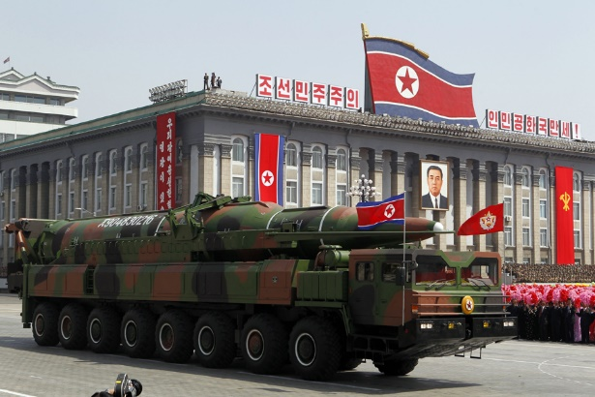

North Korean Nuclear Weapons
Possible Claims

These are possible argumentative claims that can be made on either side of the debatable issue on North Korean nuclear weapons.

North Korean Nucs Should Be Accepted, Contained, and Deterred

Any effort to remove North Korean nuclear weapons capability would start a catastrophic war on the Korean Peninsula.

Containment and deterrence can work with North Korea, just as it worked in the Cold War.

The United States and its allies have the capacity to make containment and deterrence work with North Korea.

The United States would likely not succeed in fully removing North Korea’s nuclear missiles militarily.

North Korean Nucs Should Be Eliminated by the U.S.

Accepting the North Korean nuclear capacity would lead to dangerous nuclear proliferation in southeast Asia.

With the capacity to strike the U.S. with nuclear weapons, Kim Jung-un is more likely to attack South Korea or Japan with conventional weapons, believing that the U.S. would be deterred from getting involved.

Containment and diplomacy has utterly failed as a policy to try to manage and reduce the nuclear threat posed by North Korea.

North Korean nuclear weapons could easily get in the hands of terrorists or another country that is an enemy of the United States.

