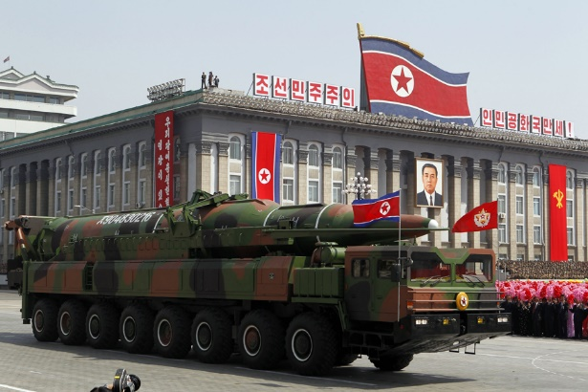

North Korean Nuclear Weapons
Possible Claims and Counter-Claims

These are possible argumentative claims that can be made on either side of the debatable issue on North Korean nuclear weapons.

North Korean Nukes Should Be Accepted, Contained, and Deterred

Any effort to remove North Korean nuclear weapons capability would start a catastrophic war on the Korean Peninsula.

The U.S. and South Korea have overwhelming military superiority and could disarm North Korea quickly.

The alternative is worse: North Korea is likely to use nuclear weapons to attack American cities.

Containment and deterrence can work with North Korea, just as it worked in the Cold War.

North Korean leaders are irrational, unlike leaders of the Soviet Union during the Cold War.

As North Korea is pushed closer to collapse by containment, it is more likely to launch a desperate war.

The United States and its allies have the capacity to make containment and deterrence work with North Korea.

But North Korea is run by an irrational madman.

The experience over the past 10 – 15 years suggests that the U.S. and its allies do not have sufficient leverage to make containment and deterrence work.

The United States would likely not succeed in fully removing North Korea’s nuclear missiles militarily.

This isn’t true: the North Korean military, outside of its nuclear weapons, is backward and unsophisticated.

The U.S. can certainly take out North Korea’s capacity to reach the American homeland with nuclear weapons, the key threat.

North Korean Nucs Should Be Eliminated by the U.S.

Accepting the North Korean nuclear capacity would lead to dangerous nuclear proliferation in southeast Asia.

The U.S. can reaffirm security guarantees with southeast Asian allies, removing their motive to obtain nuclear weapons.

Nuclear proliferation in southeast Asia might not be destabilizing.

With the capacity to strike the U.S. with nuclear weapons, Kim Jung-un is more likely to attack South Korea or Japan with conventional weapons, believing that the U.S. would be deterred from getting involved.
The U.S. has made it clear to North Korea – and will continue to make it clear – that an attack on its allies will be treated as an attack on itself, which should deter North Korea.

Our allies themselves can currently deter North Korean attack with their formidable conventional militaries.

Containment and diplomacy has utterly failed as a policy to try to manage and reduce the nuclear threat posed by North Korea.

Containment and deterrence is not intended to prevent North Korea from obtaining nuclear weapons, only from using them.

The United States hasn’t really had a coherent or consistent policy to respond to North Korea up till now.

North Korean nuclear weapons could easily get in the hands of terrorists or another country that is an enemy of the United States.

There are many other ways for terrorists or enemy states to acquire nuclear weapons.

The U.S. could deter such “rogue” behavior through sanctions and other threats.

