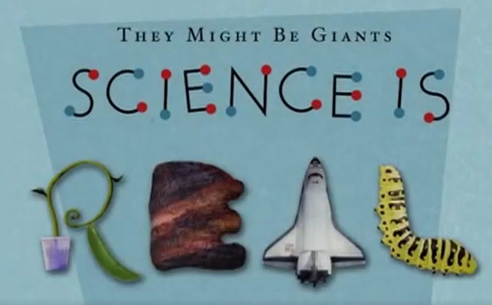
“Science Is Real” (They Might Be Giants, 2009)
Argument-Based Questions

Directions: Individually or with a partner, students should respond to each of the following argument-based questions. Then, if working with a partner, pairs should be matched with other pairs and share and discuss their responses, noting differences. If working alone, students should either be paired for a share and discuss activity, or the teacher should lead a full-class short seminar or discussion.

1. What do you think Rudolph Carnap means by the phrase “direct experience” in his definition of science?

2. How would you paraphrase (meaning: put it in your own words) the clause (meaning: long phrase, including a verb) “controlled by experimental verification”?

3. How is the phrase “science is real” parallel or equivalent to Carnap’s definition?

4. How would you summarize the main idea – in other words, the overall position or thesis – of this They Might Be Giants song?
5. What evidence does the song have that science is real, and what do you think is the best evidence? Why?

6. What does the song contrast science with? What does the song say about this contrasting way of understanding the world?

7. Identify two uses of repetition in the song. What effect do you think the use of repetition has?

8. What happens to a scientific theory, in the song’s description of the scientific method? When is a scientific theory proven true?

9. How does the song use assonance (vowel rhyming) near the end, and what point does this assonance have?

10. Why do you think They Might Be Giants felt motivated to write and produce this song?

