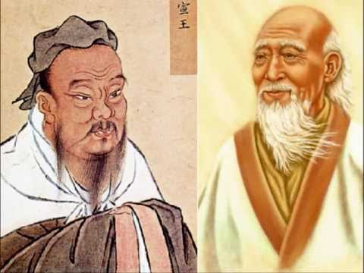
Ancient Chinese Philosophy
Possible Claims

Debatable Issue
The debatable issue for this project is:
By which ancient Chinese philosophy should people today be more influenced, Confucianism or Daoism?
The possible claims below are all exemplars and they are all viable. They are not the only argumentative claims possible, certainly.
Possible Claims for Confucianism
Confucianism believes that leaders should be fair and just to their people.
Confucianism believes in the importance of filial piety and respecting their parents.
Confucianism believes in reverence for one’s ancestors.
Confucianism believes that it is as important for people to recognize what they don’t know as it is for them to learn more.
Confucianism believes in the primary importance of wisdom.
Confucianism believes that people should be cautious and always well-prepared for changes in life.
Confucianism believes that people should think more about others than themselves.

Possible Claims for Daoism
Daoism believes in non-violence and rejects the use of weapons against other human beings.
Daoism believes in modesty and humility, especially in leaders.
Daoism believes that in a society everyone has a proper and a happy place that they will find if they let it happen naturally.
Daoism believes that all opposites are inter-connected, and that there is always some good in what is evil, some pain in what is pleasurable, and so on.
Daoism believes in a government that keeps its interference in the lives of its citizens to a minimum.
Daoism believes that desire should be abandoned and that without desire and wanting things people will be much more content and happy.
Daoism believes in the mystery of life and the spirit and believes that it is essential to embrace that mystery.

